

Faculty of Engineering and Environment

Department of Computer and Information Sciences

CM0645 Individual Project

NAME: Elliot Anderson

PROGRAMME: Computer Games Programming

PROJECT TYPE: Software Engineering Project

SUPERVISOR: Clifford Brown

2ND MARKER: Mohamed Omar

PROJECT TITLE: *Civilization Simulation Game*

**DECLARATIONS**

I declare the following:

(1) that the material contained in this dissertation is the end result of my own work and that due acknowledgement has been given in the bibliography and references to **ALL** sources be they printed, electronic or personal.

(2) the Word Count of this Dissertation is 17,425

(3) that unless this dissertation has been confirmed as confidential, I agree to an entire electronic copy or sections of the dissertation to being placed on the eLearning Portal (Blackboard), if deemed appropriate, to allow future students the opportunity to see examples of past dissertations.  I understand that if displayed on eLearning Portal it would be made available for no longer than five years and that students would be able to print off copies or download.

(4) I agree to my dissertation being submitted to a plagiarism detection service, where it will be stored in a database and compared against work submitted from this or any other School or from other institutions using the service.

In the event of the service detecting a high degree of similarity between content within the service this will be reported back to my supervisor and second marker, who may decide to undertake further investigation that may ultimately lead to disciplinary actions, should instances of plagiarism be detected.

(5) I have read the Northumbria University/Engineering and Environment Policy Statement on Ethics in Research and Consultancy and I confirm that ethical issues have been considered, evaluated and appropriately addressed in this research.

SIGNED: **Elliot Anderson**

# Acknowledgements

I would like to thank my supervisor Clifford Brown for his support and guidance in the development of this project. And Mohamed Omar for being my second marker.

# Abstract

The aim of this project is to create a sandbox game which simulates the development of civilizations as they adapt and react to the generated conditions around them.

I wanted to apply similar concepts from other games and have AI manage themselves autonomously without the need for player input.

There is a big focus in making it feel like the cities are growing as time passes. The program would first generate terrain, animals and plants and a few tribal settlements. Based on the conditions surrounding such as resource availability they develop bigger and bigger, to towns and cities. Independently the citizens will get jobs, gather resources, hunt and go about their daily lives.

There is emphasis on citizens being able to adapt and react to the terrain which is generated. Results that would like to be observed is how these citizens change the world as they grow. How much of an impact they can have and if where they are placed geographically can result in them dying out quicker than others.

Throughout the project a literature review was carried out to learn about terrain generation algorithms and world simulation, the product was designed and was then implemented based on these designs.

The product was successful in showing a civilisation adapt and react to a generated terrain and shows them making a big impact on the world in terms of what they build, and their environmental impact as animals and plants are lessened where civilisations are built. It also shows how the environment effects the civilisations as areas with less wood for example would slow down building.

Contents

Acknowledgements 3

Abstract 4

Introduction 8

**Analysis** 10

1. Literature Review – Procedural Content Generation Algorithms: Generating a suitable world in which A.I. can develop, adapt and react on. 10

1.1. Introduction 10

1.2. A look at procedural Content Generation and World Simulation in Past Games 10

1.3. What is an algorithm? 11

1.4. Procedural Content Generation 12

1.5. Terrain Generation Methods 12

1.5.1. Random Number Height Map 12

1.5.2. Interpolated Random Terrain 13

1.5.2.1 Bilinear interpolation 13

1.5.2.2 Bicubic interpolation 14

1.5.2. Gradient-based random terrain 15

1.5.3. Other Methods 16

1.6. Applying the best method to the civilisation simulation 17

1.7. Conclusion 18

2. Tools and Justifications 19

2.1. Introduction 19

2.2. Design Software 19

2.3. Equipment 20

2.4. Programming Software 21

3. Requirements 23

3.1. Introduction 23

3.2. The Requirements 23

3.3. Non-Functional Requirements 24

3.2. Conclusion 24

**Synthesis** 25

4. Design 25

4.1. Introduction 25

4.2. Mock Screenshots 25

4.2.1. Overview 25

4.2.2. Gameplay Mockups 26

4.3. Simulation Loop 29

4.4. Citizen Design 31

4.4.1. Scout 32

4.4.2. Path Layer 33

4.4.3. Gathering Jobs 34

4.4.4. Farmer 35

4.4.5. Cut Jobs 35

4.4.6. Animals and Plants 35

4.5. Civilisation Design 36

4.5.1. Spawning 36

4.5.2. Layout 36

4.5.3. Resources and Levels 38

4.6. User Interface Designs 39

4.7. Passage of Time 43

5. Implementation 44

5.1. Requirements Changes 44

5.2. Creating And Solving Problems 45

5.2.1. Programming the terrain generation 45

5.2.2. Improving the terrain generation 46

5.2.3. Citizen Movements 49

5.2.4. Steering Algorithms 50

5.2.5. Bridges 51

5.2.6. Sensing and changing the terrain types 52

5.2.7. Spawning Houses 54

5.2.8. Targets 55

5.2.9. Flow Implementation 55

5.2.10. Interacting With The World 55

5.2.11. Citizen Management 56

5.3. Testing 57

5.3.1. Internal Testing 57

5.3.2. External testing 57

6. **Evaluation, Conclusion and Recommendation** 60

6.1 Introduction 60

6.2 Evaluation 60

6.2.1. Product 60

6.2.2. Process 61

6.3 Project Conclusion 63

6.4 Project Recommendations 64

Bibliography 65

Appendix A TOR 66

Part A) Project Title 66

Appendix B Jobs 82

Jobs cut from the game 82

Builders 82

Building Manager 83

Appendix C Testing 85

External Testing 85

Internal Testing 88

Appendix D Requirements Table 89

Appendix F Passage Of Time 98

Appendix G Programming the Terrain Generation 100

Appendix H Flow Implementation 103

Appendix F Code 111

# Introduction

The aim of the project is to create a sandbox game which simulates the development of civilizations as they adapt and react to the generated conditions around them.

As a student of computer games programming, the simulation aspect of games was always intriguing. There are games out there such as “settlers” which allow you to manage your own settlement. However there are not many where the citizens manage themselves without the need for a player.

I wanted to apply similar concepts from other games and have AI manage themselves autonomously without the need for player input. Though it is debatable whether the end result could be considered a game it is no doubt a sandbox, where it is defined as a virtual space (in this case a simulation) where the user can inspect and interact without goal.

There is emphasis on citizens being able to adapt and react to the terrain which is generated. Results that would like to be observed is how these citizens change the world as they grow. How much of an impact they can have and if where they are placed geographically can result in them dying out quicker than others.

The software will allow users to manipulate the camera, speed up time and look at data on every individual in the game. They can also interact with the world themselves by morphing the terrain.

There is a big focus in making it feel like the cities are growing as time passes. The program would first generate terrain, animals and plants and a few tribal settlements. Then based on the conditions surrounding such resource availability they develop bigger and bigger, to town and cities. Independently the citizens will get jobs, gather resources, hunt and go about their daily lives.

The first section of the project is the analysis section this includes a literature review. Procedural generation will be researched to create the environment and world. Another subject would be game artificial intelligence as the citizens communicate and work together to create their civilizations. The analysis section also contains a section on all the tools that will be used and will talk about the requirements for the project.

The second section is the synthesis section, this includes the first part which goes over the designs. What goes into the mechanics, gameplay, UI and AI. It goes over why things are designed the way they are and the ways in which they were achieved. The second part is the building or implementation stage. This goes over how certain mechanics were programmed and implemented and any issues that were encountered along the way. The final part of this section is testing which talks about the feedback and how tests were used to improve features.

The evaluation is the final section of the project which investigates what went well and what did not go well. After this was the recommendations which talks about what could be done with the project in the future and a conclusion which goes over if the aims were achieved and what can be concluded from it.

The product was successful in showing a civilisation adapt and react to a generated terrain and shows them making a big impact on the world in terms of what they build, and their environmental impact as animals and plants are lessened where civilisations are built. It also shows how the environment effects the civilisations as areas with less wood for example would slow down building.

# Analysis

# 1. Literature Review – Procedural Content Generation Algorithms: Generating a suitable world in which A.I. can develop, adapt and react on.

## 1.1. Introduction

To achieve terrain generation, this project will need to use an algorithm which can get the desired results efficiently. Therefore, before the development of the game is started, it is important to research what an algorithm is, the different kinds of algorithms and compare which one will be best for the job.

Furthermore, the generated world must meet specific requirements such as customizability and suitability for a world in which A.I. can develop, adapt and react on. That is what this section will cover.

Past games will also be looked at which use world simulation to see how they go about approaching it and if there is anything that can be applied to the civilisation simulator.

## 1.2. A look at procedural Content Generation and World Simulation in Past Games

Before looking into generating worlds and procedural content generation it is a good idea to look at past efforts in this field. Before talking about this it is important to note that procedural content generation is defined by the automatic creation of game content using algorithms or processes which can produce a vast array of possible content. This is according to (Georgios N. Yannakakis, 2015)

According to (Amato, 2017) procedural content generation was first used to compress data so that as much content could come from as little hard drive space as possible. The first game to use a seed to generate a game world was ( Akalabeth: World of Doom, 1979 ) Creating big dungeons for the game would have taken up too much space on the Apple II which it was released on. So using procedural content generation allows possibly infinite dungeons within a very small amount of space.

Another game that did this was (Elite , 1984) which used procedural content generation to create 8 galaxies with 256 solar systems each. Not only that but each solar system had multiple planets with their own space station, name terrain, details on locations, prices and more. This was incredible for the time and was all done within an 8-bit computer. Also, according to (Amato, 2017) this was achieved by having a seed number which is ran through an algorithm which in turn generates a sequence of more numbers which determine all of the details on planets and such.

Despite the game being old, the same method is still applied to games today and will be used in a similar way to simulate a world for this project.

## 1.3. What is an algorithm?

Before looking into specific algorithms for procedural terrain generation, it is essential to understand what an algorithm is. In the book ‘Python Algorithms: Mastering Basic Algorithms in the Python Language’ (M, 2010) it is stated that an algorithm is a procedure with a finite number of steps that can solve a problem in a given time.

Simply a procedure, involving steps which solve a problem. However, that is all an algorithm is on a fundamental level. The book ‘Data Structures and Algorithms’ (Aho A, 1983) talks more in detail about what an algorithm is with more emphasis on it being finite. It states that an algorithm needs to terminate after executing a finite number of instructions. Therefore, a program is only an algorithm as long as it never enters an infinite loop.

This coincides with the terrain generation required for the project. The algorithm would execute the terrain generation algorithm, then finish when the terrain has been completely generated. The artificial intelligence in the game is infinite and could loop forever. Therefore, the artificial intelligence cannot be classed or solved with an algorithm.

The book gives an example of an algorithm; in this case it is a sorting algorithm. It describes that in a sorting problem a list of items is given as input. These items are produced at output but reordered to have the smallest or largest first. For example, “2, 1, 3, 1, 5, 8” given as input would produce “1, 1, 2, 3, 5, 8” at output.

From the example it gives, and from what is stated in both books, algorithms usually require an input to produce an output. The terrain generation in the simulation game’s input will be what is known as a seed, which the algorithm will use to generate the landmass.

## 1.4. Procedural Content Generation

Procedural content generation will be shortened to PCG in this chapter. As described in the book procedural content generation in games (Shaker N, 2016) procedural content generation is the creation of game content through algorithms with input from the user. These methods are created for many different reasons such as saving development time and costs, increasing replayability, allowing for adaptive games, assisting designers and studying creativity and game design.

In the case of the civilisation simulator game, PCG terrain is integral to the gameplay rather than an enhancement.

The book goes on further to say that a PCG solution is supposed to be fast, reliable, controllable and expressive. However, some trade-offs need to be made between the properties when choosing an algorithm.

For the civilisation simulation game, it is best that an algorithm is found which is fast, controllable and easy to implement as there is not a lot of time to work on a really complex algorithm. Though it doesn’t have to be complex, it still needs to be able to generate terrain that looks good efficiently.

Let’s look at some ways to generate terrain and pick the best one for the project.

## 1.5. Terrain Generation Methods

Terrain generation is made up of multiple different algorithms all working together. This section will describe the various methods and algorithms involved in their creation.

### 1.5.1. Random Number Height Map

According to (Shaker N, 2016) the process can be described in its most basic form by utilising height maps. Wherein it is represented by a grid where a different height represents each cell. Technically a map could be generated by picking values at random. However, this leads to very unnatural looking maps spiking up in a random and ugly way. This makes it so that there are no flat portions, mountain ranges or hills and other features you would usually associate with terrain.

The main issue about this method which causes issues is that each number is independently generated while in real terrain heights at different points are not independent. All the points in real terrain are associated with each other and statically related to elevations around nearby points.

### 1.5.2. Interpolated Random Terrain

There is an algorithm to make the landscape less unrealistically spiky; this involves interpolating between the numbers. When using this method, random values are not generated for every single point on a heightmap. Instead, values are randomly generated on a coarser lattice.

All the heights amongst the lattice points are interpolated so that the random heights are connected. Simply, the elevations for peaks and valleys are generated with certain spacing, and the slopes are filled between them. However, the question is how to achieve this interpolation. There are multiple different interpolation algorithms which can be used each with having their own trade-offs for the quality of results and computational time needed.

### 1.5.2.1 Bilinear interpolation

Bilinear interpolation is a simple method of interpolation where a weighted average is calculated in two directions, horizontal and vertical. Here is how to do the algorithm according to (Shaker N, 2016);

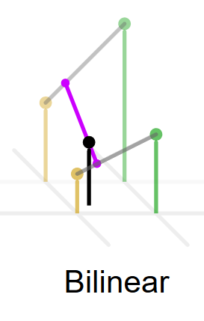

Figure This picture shows a 3D graph representation of the maths behind Bilinear interpolation. As you can see the lines are steep and sharp. When applied to terrain the mountains will also be steep and sharp so may not be ideal.

If a lattice is picked one tenth the detail of the resolution then height at the position [0,0] and of [0,10] will be a couple of the values which were randomly generated.

In order for [0,1] to be filled in, this point needs to be understood that it is 10% of the distance between the heights of [0,0] and [0,10]. This can be put in terms of a calculation called a weighted average, and in this case it is: height [0,1] =0.9 * height [0,0]+ 0.1 * height [0,10].

According to (Jane Grossman, 1980) a weighted average is a mean wherein each value is giving different levels of importance or weight. This will contribute to a different value if some values were not weighed.

Back to (Shaker N, 2016) this is the interpolation in the x direction, so we would have to do the same in the Y direction. You call this bilinear interpolation, as it does the linear interpolation across two axes. This method is easy and efficient to implement over other interpolation techniques.

The algorithm maybe simpler than other interpolations, however it has drawbacks. These are things like the mountain slopes becoming perfectly straight line, and all the peaks and valleys become very sharp points.

### 1.5.2.2 Bicubic interpolation

A better but more complicated interpolation algorithm is the bicubic approach. As an alternative to the previous approach’s pointed peaks and valleys with straight slopes connecting them bicubic can be used. These make the connections much more curved in shape, which is called an S-curve. Slowly the slope rises and grows more steep as it is moved further up the mountain. It will then level at the top in a much rounder peak. According to (Shaker N, 2016) this is how the algorithm works;

This interpolation is produced in a way where it is interpolated non-linearly. When ten percent of the distance between the lattice’s it should not be ten percent in the vertical distance of the slope at the same time. This is because it is wanted to be a slow curve up and not a steep curve. This is why it needs to be interpolated non-linearly between neighbouring lattices, as doing a weighted average will not produce the right kind of results.

So the way to interpolate bicubically is to use a slope function which specifies how far up the slope it is vertically when it is at a certain point on the x axis or horizontally. The bilinear interpolation function looks like s( x ) = x so this needs to be changed to also include an s-curve. Countless functions have the s-curve that is needed but a good one to use with in conjugation with computer graphics is is s(x) = −2 x 3 + 3 x 2 due to it being fast and simple to evaluate.

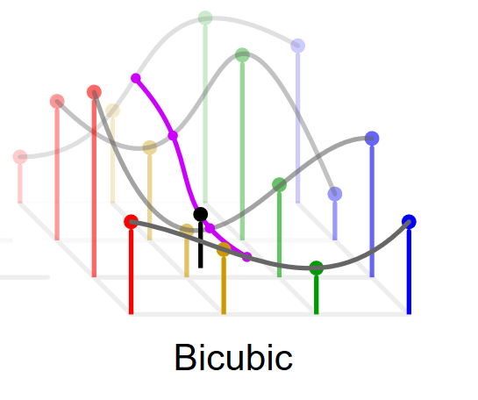

Figure This picture shows a 3D graph representation of the maths behind Bicubic interpolation. As you can see the lines are much more rounded and smooth, with varying curve sizes and inclines. This is much more natural looking than bilinear and therefore the generated terrain created with this should reflect how these lines look.

With this new function, when ten percent along the x axis it should only be 2.7% up the slopes vertical height. In bilinear interpolation it would be up 10%. Therefore, the slope will become much more gradual.

Now the height [ 0,1] should be equal to = 0.972 × height [ 0 , 0 ]+ 0 . 028 × height [0 , 10]. This function is a cubic function of x or third power. So it can be applied again on the interpolation through both directions on a 2D grid.

So in the end there is a much smoother, less sharp interpolation with varying curve sizes and inclines. It is much more varied and is a much better method than bilinear albeit slightly harder to implement.

### 1.5.2. Gradient-based random terrain

All the previous examples of terrain generation algorithms, first generated random values then plugged them into the heightmap. The first algorithm talked about generating the heights directly but ended up too noisy. After this the values were generated for a coarse lattice with the slopes being interpolated between each other. Once bicubic interpolation is used, a smooth slope is produced.

A completely different way of doing it is instead of generating height values then interpolating the slopes, but generate the slopes directly and deduce the height values from it.

The generated random numbers will be interpreted as random gradients or otherwise knows as steepness and direction of slopes. This is called gradient noise and was created by Ken Perlin, of which this type of noise was named after him as, “Perlin Noise.”



Figure This image shows what generated perlin noise looks like before being applied to a height map. Think of the shades as different levels of height. This can be used to create an island.

Gradient based generation has many advantages over generating height values. There is an extra level of smoothness due to the interpolation of gradients. This is as opposed to smoothing the changes of height with an interpolation algorithm. Also with the interpolation of gradients the rate of change in heights is also smoothed so slopes grow shallower and steeper smoothly.

It also has the advantage of using lattice-based generation, which is much more memory efficient while avoiding the grid effect which appears when the interpolation algorithms are used instead. It also looks more organic as peaks and valleys are not generated on lattice points as they emerge from rises and falls in slopes.

Here is how the algorithm works according to (Shaker N, 2016);

With the previous interpolation based terrain generation, the numbers are generated on a coarsely spaced lattice, with the interpolation happening between these lattice points. But with gradient based generation it is now generated on a 2D Vector which is represented as dx,dy, at every single lattice point. This is as opposed to being a single a value on each lattice. Dx and dy is a representation of a random gradient and is how steep the slope is in the directions of x and y.

Each value for the gradient can be either positive or negative. Positive being a rising slope and negative being a falling slope. There just needs to be a way to retrieve height values from gradients. This is done by initially setting a height of zero at each lattice. The zero value is not always just a midpoint as it can be put at any location. This is because valleys and peaks can increase to all different heights and different slopes.

So, to find the height value, four neighbouring lattices are looked at. To work it out let’s look at the top left gradient, if the terrain rose or fell from h=0 what would it be? It would be the value of the gradient multiplied by distance that has been travelled along. So, it would be the x axis (dx) multiplied by the distance to the right of the lattice added to the slope of the y axis (dy) multiplied by the distance down from the lattice.

Using vector arithmetic, it is the dot product from the gradient vector to the vector drawn from the lattice point to the current point. It is then repeated for all four of the surrounding lattices. With this there are four height values which tell the height of the terrain if the only influence on the height was one of the four neibouring points.

These can all be combined by interpolating the values.

### 1.5.3. Other Methods

There also exists a group of algorithms which are known as fractal methods which can look even more natural than noise based methods. In real terrain, there is variation at all different scales. With something like noise based terrain, it is generated at large scale. Plains rise into mountain ranges for example. With fractal based methods it is at a much smaller scale so there is much more minute details such as the peaks and valleys of mountains, and those valleys having smaller hills and ravines.

This is based directly on fractal mathematics and is also similar to how a fractal works in a way as zooming in will repeat the same pattern at smaller and smaller scales again. Diamond-square algorithm is a commonly used fractal method, though these are much too detailed for this project.

Another method focuses more on travers-ability or other kinds of gameplay considerations. These are known as search based methods. Search based methods are more appropriate for tightly designed games however such as an RTS game which may require paths, labyrinths and other things fit for that kind of gameplay. There would be no point using this on the civilisation simulation as there is no requirements for these.

## 1.6. Applying the best method to the civilisation simulation

After going over all the methods of terrain generation, it is essential to decide which can be applied best to the civilisation simulation game. Things that must be considered are its ability to be utilised in a 2D game rather than a 3D terrain which the previous methods describe.

It also needs to work good in conjunction with A.I as they adapt, react and develop to the generated conditions. Which means all terrain must include specific elements to work and must always generate every time a new terrain is created.

These sorts of things would include a river, a source of wood and a source of stone. It would also need all the biomes so that every person has a similar experience no matter how many times a new map is generated. These would be things such as snowy mountains, beaches and woodland.

Since the A.I needs to react to these conditions, it must be traversable. For example, there can’t be loads of random spikes in the terrain in random places. Something that could trap villagers in the middle. It must also be coherent and look like an island. Random splodges of woodland, snow and sand would not be believable. It needs to follow at least a little bit of realism while staying relatively simple.

So which method will be used? Interpolated random terrain is a good option for 3D terrain but cannot be applied easily to create tile based 2D terrain. This is due to the fact the random numbers are directly generated on a height-map which is a 3D based object. It is possible to interpret a height map in 2D space but is a lot of work for something that could be generated a different way. The best method to use would be noise based methods such as a gradient-based random terrain which uses Perlin noise. Not only is it easy to set up in 2D due to the interpretation of noise being able to be efficiently applied to a 2D plane, but this method is a lot less maths intensive too yet is still very customizable.

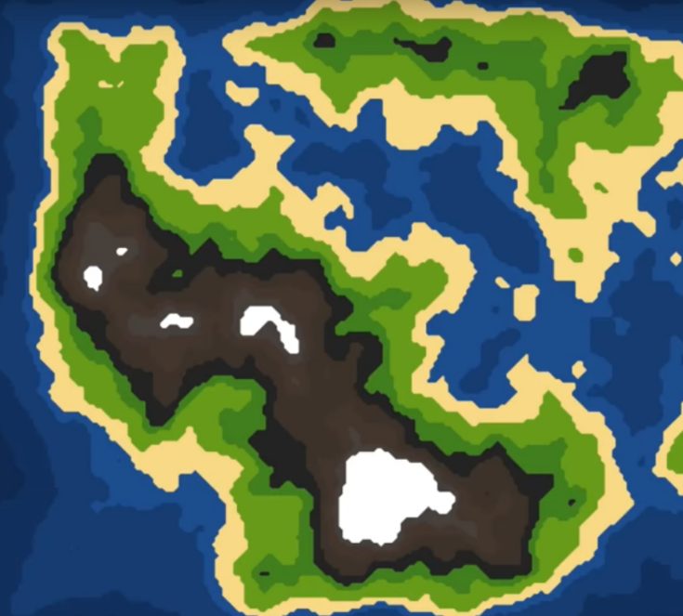

Figure This image shows how the finished terrain could look after being generated. (Lague, 2016)

The question is how to go about this in unity. Sebastian Lague has a video series on YouTube about procedural landmass generation and goes over how this can be coded in Unity. Though his series focuses on 3D terrain, it should be easy enough to reinterpret some parts to use tiles or colours rather than a 3D height map.

The series talks about generating heightmaps using Perlin noise then assigning terrain types to the various height ranges. (Lague, 2016) While this series applies it to 3D terrain, my terrain will be reinterpreted to work with 2D tiles with assigned types and such so that AI will know precisely what each tile is.

## 1.7. Conclusion

In conclusion, we have learned that we will need to use an algorithm to generate the world and that an algorithm is only an algorithm if it never enters an infinite loop. Therefore an algorithm cannot be used in the AI as this is something that lasts forever.

We also learned about procedural content generation, and it's requirements to make the world in the game, and have compared all the different kinds of terrain generation methods and which are most suitable for A.I to develop, adapt and react upon.

These methods bilinear interpolation, bicubic interpolation, gradient-based random terrain and a few other techniques.

It was decided in the end that the best method to use would be noise based methods such as a gradient-based random terrain which uses Perlin noise. Due to it being easily applyable to 2D and due to it's less maths intensive approach while still maintaining customisability.

# 2. Tools and Justifications

### 2.1. Introduction

The project will make use of many different tools and resources which are needed to carry out a whole range of tasks. This encompasses anything from the software used to design the software, to general equipment and programming software. It is important to analyse all the possible tools and make a choice on the best one. This is what this section is about.

### 2.2. Design Software

Word Processor

First and foremost a word processor is needed to write up the documentation and designs and almost everything relating to the project. This was the first tool which was needed to decide on as even the initial write-ups relied on it. There are a few choices that were considered before starting the project. These were; Microsoft Word, Open Office and google docs.

Ultimately Microsoft Word was decided on due to its ease of use, compatibility and speed. The advantages open office and google docs had over word, were their price as these were completely free. Usually word can cost hundreds of pounds, however thanks to the Uni there was no need to pay for it as a student.

From experience, open office was less intuitive and compatible and generally slower. Google docs fared better, though it required an internet connection which is not ideal. It was also still quite a bit slower than word.

Image editor

Image editing is needed in every facet of the project such as designing, concept creation, and creation of graphics. As a result, a fully featured program is needed which can be used in a range of different scenarios.

Although there are many editors available, there are two main contenders that were considered. These were; Adobe Photoshop and GIMP.

Adobe Photoshop is an extensive image editing program, with many features fit for every scenario. It is easy to use and the number of things you can do are endless. However, this comes with a rather hefty price tag, which ranges from manageable monthly payments, to over £1000.

GIMP is an open source free image editing software, which like photoshop has a lot of potential in what you can do with images. However, gimp comes with a little steeper of a learning curve as it is less intuitive, and the interface is much clunkier. Though when mastered it can be just as powerful as photoshop.

In the end photoshop was chosen due to having experience so can use it to its full potential. The price would have been a big issue however there is an old disc which can be used. Though the version is old, it is still as fully featured if not more than GIMP and with previous experience with it is a slightly better option than GIMP. Furthermore, photoshop is available to use on University computers so it should not be an issue to find the software.

For minor and minor image editing such as cropping an image, a program called “Paint.net” will be utilised. This is open source and free like GIMP though it has much less features. However, it is very lightweight and easy to open very fast and edit. As a result, it can be used for quick adjustments of images.

Diagrams

Diagrams are a great way to express designs in an easy to read visual way. This can be used in visualising programming with UML diagrams and other concepts using flow charts for example. Though it is possible to create these by hand, software would be very useful as they are easy to edit and will always look tidy.

The software that were considered for creating diagrams are Microsoft Visio, StarUML and draw.io. Microsoft Visio is software which can be used to make any kind of diagram type imaginable. It has many features and is great for flow charts. However, it costs quite a bit of money to buy.

StarUML comes in two versions, version 1 and version 2. However only version 1 is free and open source and therefore is the one being discussed. Though it does not have as many features as Visio, it is very good for creating UML diagrams as that is what it specialises in.

Draw.io is a good all-rounder diagramming software. It is free, web based and can be used to create many kinds of diagram types. The disadvantage of course is that you need internet connection to access it, which could be problematic if no internet connection is available. This is easily avoidable though, since for the most part internet will be available almost all the time.

In the end a combination of StarUML and Draw.io was decided. StarUML, primarily, will be used for UML diagrams, as they are easy to create in it. Draw.io will be used for everything else such as flow charts as it is very good at doing that. It may not be as feature complete as Visio, but it gets the job done and comes with no cost. Therefore, a combination of the two was chosen.

### 2.3. Equipment

Computer and Laptop

The first piece of equipment that will be needed is a device in which most of the work will take place. As the project is software based, a computer is required. The computer should be fast enough to cope with the software which will be used. The university provides decent computers which should be adequate to run unity. Furthermore, a powerful gaming laptop is available for use.

The computer and laptop will also be used during testing, to have people examine the software.

Keyboard and Mouse

A keyboard and mouse will be used as the controlling method of the game, as it is the best way to play. As the game makes use of pointing and clicking, a mouse would be fast and easy to use.

Other methods considered were using a gamepad. With a gamepad, you would need to push the buttons to move the in-game pointer. This would be too tedious compared to the direct input that a mouse gives you.

### 2.4. Programming Software

Game Engine

The game engine will be one of the most critical software involved in the creation of the game. It is the backbone for which the whole game will rely on. A game engine is a software framework with game development in mind.

Different engines have different features, advantages and disadvantages. These need to be reflected on when choosing the right engine for the job. There were four main engines to consider.

The first one is creating an engine from scratch. This would involve designing and programming an engine using a selected programming language.

One advantage of creating an engine from scratch is having full control over what the engine will specialise in. General game engines need to have all game types in mind while creating one from scratch would enable efficiency in some areas more than others. For example, as the project makes significant use of terrain generation, it would be possible to program it in such a way that terrain generation is more efficient and easy to implement than say 3D effects, which would not be useful for the game.

Another advantage of creating an engine from scratch is the familiarity of how it works. Using an engine built by someone else has the disadvantage of having to learn how it works, while if the engine was created from scratch, you would immediately know how to use it. Being a master of the engine would also mean you could get things done quickly once the engine was created. However, this leads on to the disadvantages.

It would not be feasible, especially under the time constraints, to develop an engine from scratch. Not only would it take too long, but it would also be a massive undertaken requiring further study into how to put the engine together. This would substantially offset when work on the actual development of the game could take place.

The Godot engine was the second to be considered. It is a community developed, open source game engine. Initially this was the engine that was going to be chosen; however, there were a few disadvantages which dissuaded its use in the project. Though firstly the reasons why it was going to be picked;

The first advantage is that the engine is open source and under an MIT license. This means that if a game created using the engine were to be published there would be no royalties required to the creators of the engine. This would be great if money was intended to be made from the final game.

Secondly, it uses real 2D rendering as opposed to the two other engines, Unity and Unreal. These engines choose to render 2D in what is essentially a 3D world but with the z-axis locked. Godot doesn’t do this and is therefore much faster to render 2D graphics, which is perfect for the game as it is entirely in 2D.

Finally, the engine is lightweight, easy to use and powerful. As opposed to the other engines like Unity and Unreal, Godot is only a little over 16MB. The exported game file will also be a lot smaller than what other engines can produce too. This means the engine and the game will be easily transferable to other computers, allowing the workflow to be a lot quicker when transferring from the computer from home and at University. Despite the small size, it is very powerful, and providing the game is 2D, you can do anything within.

However, there were disadvantages which dissuaded its use. The first one is the absence of a programming language that I already know. The most recent stable release only allows you to program in a scripting language known as GDscript. While the scripting language is straightforward to learn, a language which can be used in other engines is preferred. GDscript is not used elsewhere, so skills learned with this language would not be able to be applied outside of this engine. You can use C# in the unstable Godot 3.0. However, it would be better to stick to stable releases as they are more reliable.

The second disadvantage is, it is much less prevalent than engines like Unity and Unreal. Therefore, it would be harder to find help if trouble was to be ran into. There are forum posts upon forums posts detailing the many issues users have, in Unity and Unreal. That amount just isn’t there for Godot.

Therefore, the final decision is between Unity and Unreal. Unity is a game engine created by Unity Technologies, and Unreal Engine is an engine created by Epic Games. Both engines can make games in 2D and 3D though both are better at different things. Unreal’s default 3D settings are much more graphically intensive and photorealistic. Unity’s 3D is also excellent, though It lacks a little of the photorealism that Unreal has. However, Unity’s 2D is a lot better than Unreal. While both engines use fake 2D, Unity was built with making 2D games in mind. Unreal simply was not, and therefore 2D is not very well optimised and is much harder to use. So this brings Unity ahead in that regard.

Unity allows scripting in C# while Unreal enables you to program in C++. These languages are ideal since I know both. Unreal also uses something called blueprints which is essentially visual scripting. However, programming the usual way is much preferred so this is of no benefit to me.

From experience, Unity was found to be easier than Unreal. It seemed everything took a lot more steps to get working in unreal, while Unity was much more straightforward to attach scripts and just get things working. Unity’s interface was a lot easier to navigate too. So, Unity is preferred here too.

# 3. Requirements

## 3.1. Introduction

Requirements are important as they allow you to see what features need to be made and prioritised. They give you and those who read it a clear understanding of what the project will achieve and how it should function. The project becomes a lot more organised with a detailed requirement list constructed.

## 3.2. The Requirements

Requirements are listed in a table, grouped in categories. They cover everything that the game should have and will need to be implemented. Each requirement is described and then justified for the reason it was selected. The approach to selecting requirements was to go through everything that the project would possibly need and writing it down. While researching it becomes apparent what is needed from the project.

Requirements are needed so that no aspect of the game are left out, it allows you to overview everything that is needed. Based on that, it is easier to allocate time to the requirements which are most important. It is also not always apparent how much work will be needed, therefore breaking it down into a requirements table allows you to get a better picture of the amount of the amount of work that is needed. Something may seem easy when thinking about it, but when you break it into individual bits of work you can see there is a lot more to it.

My requirements are separated into categories, such as requirements to do with menus or requirements to do with generating maps. These are some noteworthy requirements, see the table in the appendix for more.

The game requires there to be a generated terrain map which features multiple different terrain types. The map needs to appropriately accommodate the mechanics of the AI, and their city building. Therefore, whenever a map is generated it must feature a suitable area for cities and civilisations to grow. The terrain types must also generate in a way that makes sense. For example, a map generated that looks like incoherent noise and no discernible features of an island would not be appropriate to the game and would not be useable to the AI.

A map requires a sufficient balance of water, woodland and stone and a distributed population of plants and animals. This is so that at least one civilisation can thrive with enough resources.

Another important requirement covers the specific behaviours which all the different A.I will inhibit, such as woodcutters head to the nearest wood to chop trees, hunter-gatherers gather edible plants and kill animals and farmers grow and farm animals for food.

## 3.3. Non-Functional Requirements

The requirements table only covers functional requirements, so these will be talked about here. The main non-functional requirements require that it be:

* Easy to use
* Have good performance
* Be compatible with many computers
* Have as few bugs as possible.

It must be easy to use so that users can control the simulation without issue as this can be frustrating. It should perform well as if the software runs too slow it can get in the way of achieving its goal of being a good simulation. It can be harder to tell what is going on.

It should be compatible with as many computers as possible as there is no point to creating the software if few people can use it or if it were to be implemented into other products.

It should also have as few bugs as possible as these can again frustrate the user and downgrades the quality of the build.

## 3.2. Conclusion

In conclusion writing a requirements table is a major part of the process of synthesising the final product. Since it allows you to easily lay out all things that need to be done, and to grasp the general scope of the product and to apply the right amount of time for each requirement.

# Synthesis

# 4. Design

## 4.1. Introduction

As part of creating the game, many aspects will need to be designed such as those included in the requirements table. All these designs will be documented, with a full design document in the appendix.

## 4.2. Mock Screenshots

To assist in designing the game, mock screenshots were produced to give a general overview of how the game will look and feel. This helps create a basis for what I’m about to design and allows me to envision how things will look more clearly. Elements included in the mock screenshots is the map design and a basic user interface used during gameplay.

The mock screen-shots are not actual gameplay and so won’t be completely representative of the final product.

### 4.2.1. Overview

This mock-up (Figure 5) shows how a generated terrain could look. It is shown with all the terrain types that need to be generated such as water, grass, forest, sand and wood. The shape of the island with enough space was considered when creating the design.

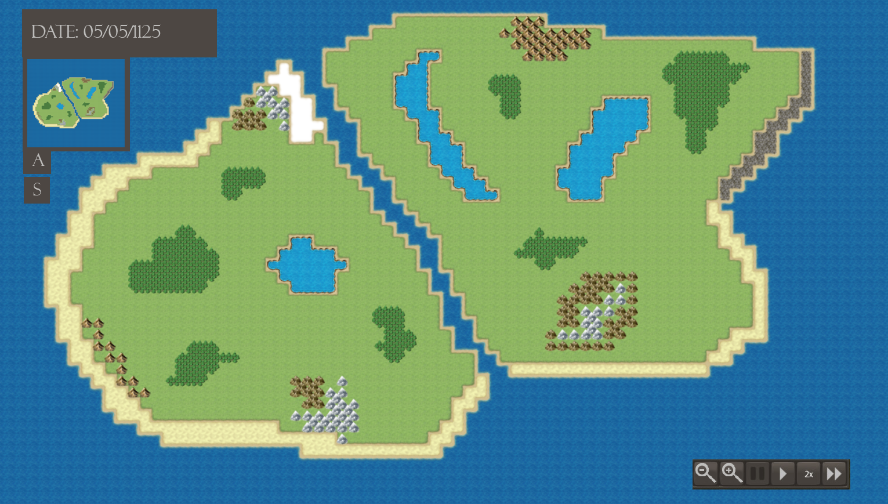It also shows a user interface design which includes the in-game date, actions menu, stats menu, a zoom in and zoom out button, a pause time and fast forward time button, as well as a minimap to show the whole map even when zoomed in.

Figure Mock-up

### 4.2.2. Gameplay Mockups

Also to get an idea how the game will play, some examples of what can happen during gameplay were created.

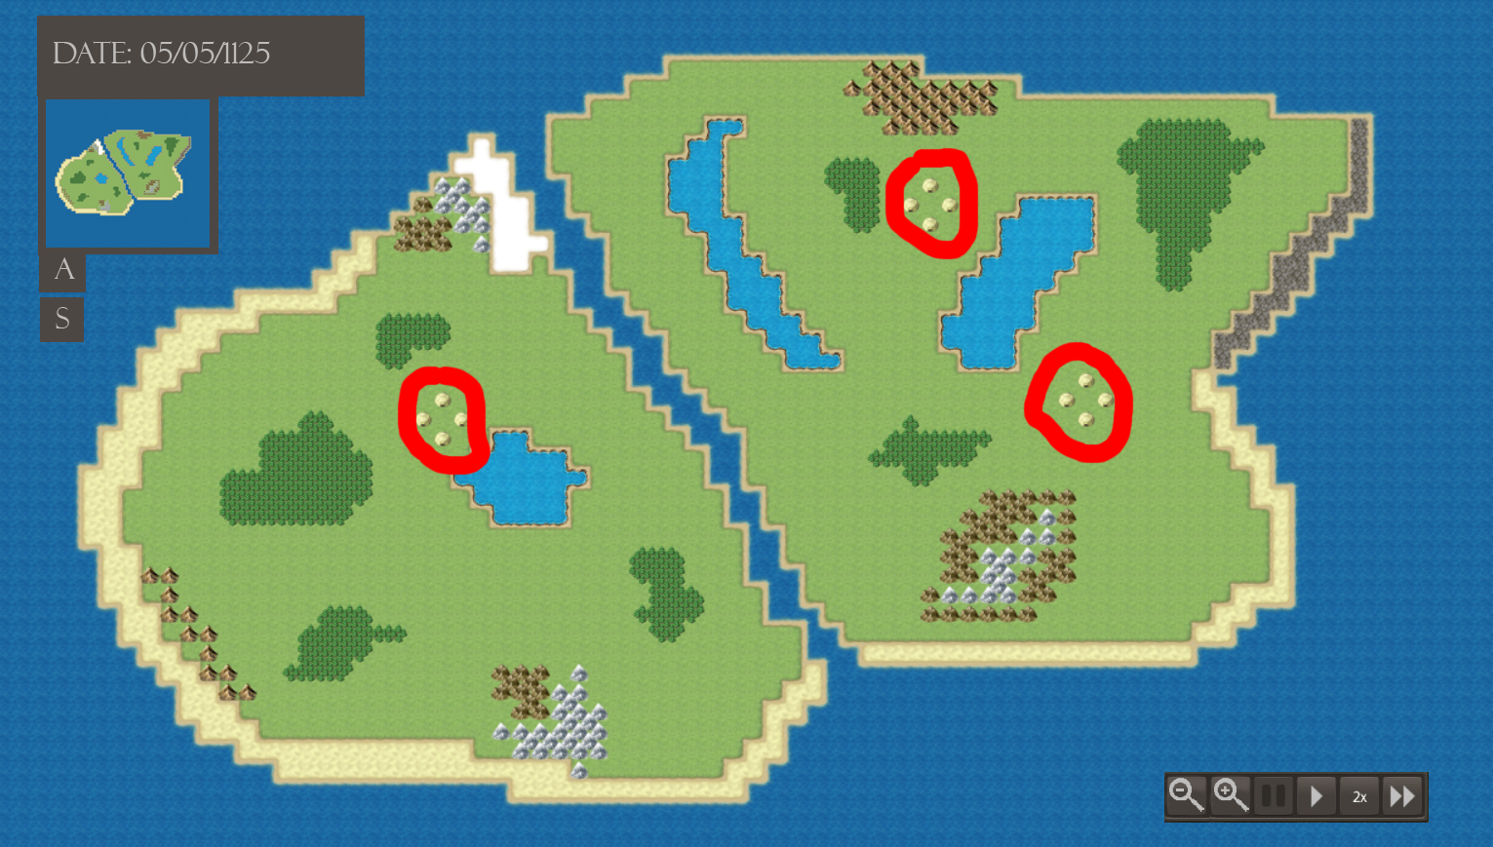At the beginning only, tribes will be created.

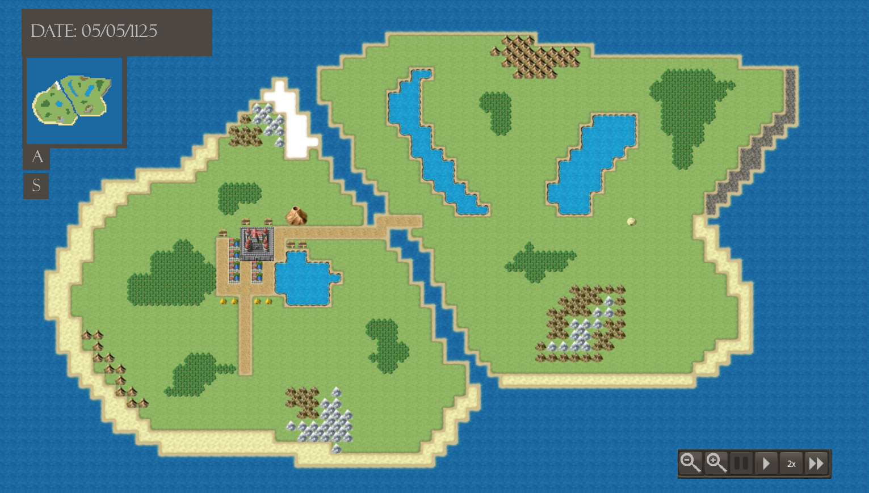As time goes by these will evolve into towns, at this point in time only one tribe has evolved to become a town, where they will create roads, houses and farms.

When you zoom in, it will look something like this. However, in the final game, you will be able to see each citizen where you can click on them to see their individual stats such as their generated name, when they were born and their profession. They also move around in real time which can also be sped up. You will be able to see them build houses and travel to areas to gather resources and such.

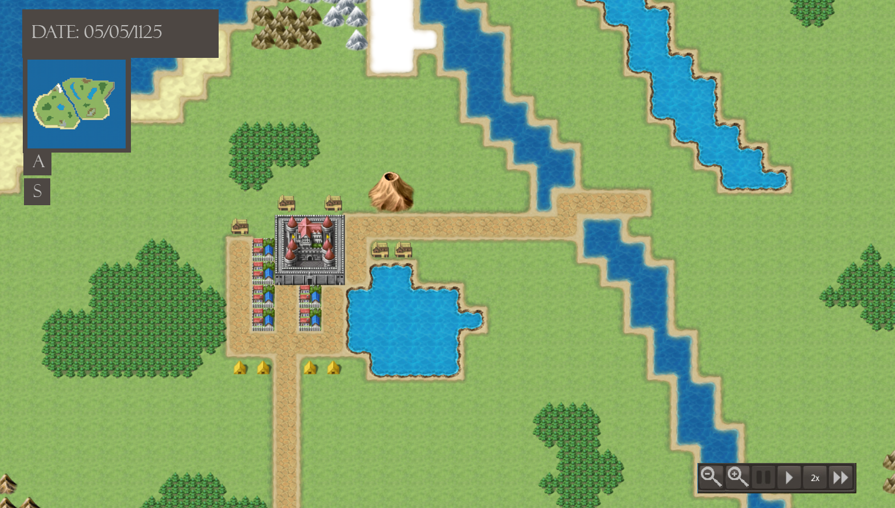As the player, you can mess with the world to see the civilisations adapt to change. In this case, we have made a volcano erupt. Events such as these can also happen without player intervention. The town will react by relocating to a better place. But much smaller as many people may die.

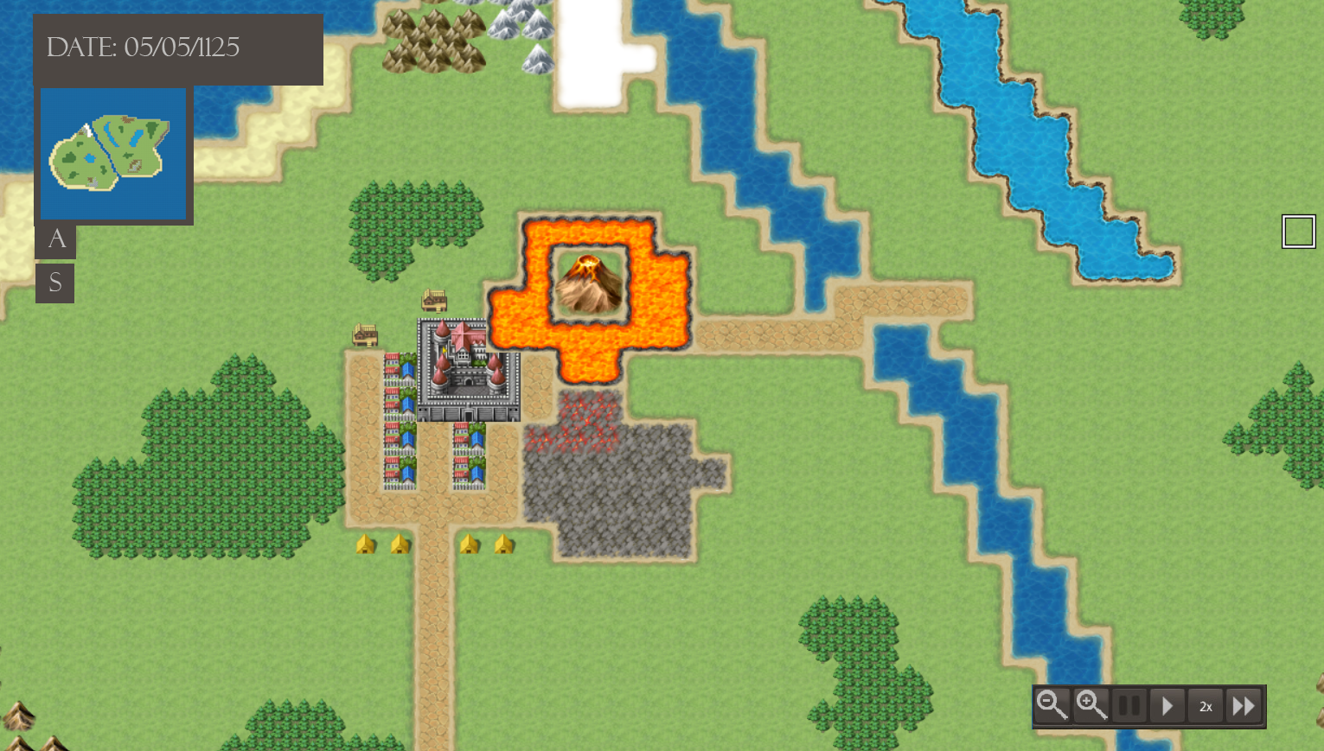

## 4.3. Simulation Loop

In video games, the whole flow of the game happens in what is known as a gameplay loop. When boiled down in the most basic way it can be represented by the picture below.

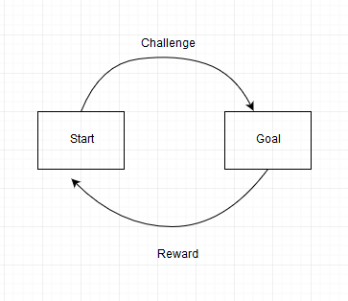

The player starts the game, there is a challenge they must overcome, they complete the challenge and are rewarded then the game starts again. The civilisation simulation is not a game and described more of a sandbox, so this loop can’t be applied to it. However it is a very similar concept.

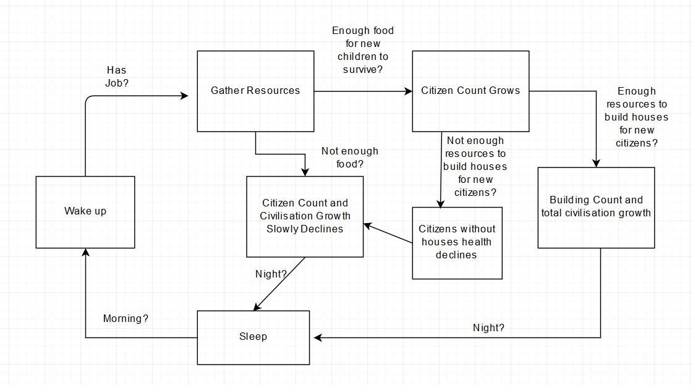

The above flow chart is the simulation loop in very basic terms without going into detail on individual concepts. The start of the loop is the box which says wake up. This refers to the citizens waking up in the morning. If the citizens have jobs they will be gathering resources for the civilisation.

If there is enough food more children will be born and can survive. This makes the citizen count grow. If there is not enough food the citizen count will slowly decline due to children not being born and potentially not enough to feed the current population.

So, after the box where citizen count grows, if there is enough resources such as material to build more houses for them to live in the overall growth of the civilisation will continue to increase and cover more land. However if there is not enough resources new houses won’t be built and therefore their health will start decreasing. This leads to a decline in population.

At the end of the day all citizens go to bed until they wake up again where the loop will restart.

These are the basic principles of the simulation loop. Basically there needs to be equilibrium where an increased population will get more and more resources contributing to more growth. If one of the equilibrium is set off such as not enough food, the population will continue to decline until it is stable again.

## 4.4. Citizen Design

The citizens are the individual people that make up a civilisation and drive it forward or back in growth. You can think of it like an ant colony as each citizen has a basic job that they do each day for the benefit of the colony. Though their jobs may be different they all need to share some common stats, behaviours and variables.

It is worth noting that each citizen has characteristics based on real people though much more simplified. The simulation cannot

Each citizen is either born male or female, this is randomly determined at birth at a 50/50 chance. Due to this there will always be similar amounts of males and females per civilisation. The sprite of the citizen is also different whether they are male or female.

Based on the citizen’s gender they will be given a random name. If they are not born to anyone in the world they will be given a random second name. If they have parents they will inherit the second name from them.

Each citizen ages with the passing of time, although unlike real life citizens they have two ages. Citizen age and earth age. This is because unlike real people citizens count their age in days. This is due to the fact the simulation is an abstraction of real life. If changes were to be observed by the user, time needs to progress quicker, citizens need to age quicker and events need to take place faster. So when a citizen is 18 in citizen age they are still less than one in earth age which is the measurement of actual years. This is talked more in-depth in the passage of time section.

Each citizen has a health variable that starts at 100. They will lose health if they have not been fully fed or don’t belong to any house. When the health reaches 0 they will die.

Citizens have a variable to store their current job and state. The state is what they are doing at that moment such as their job maybe woodcutting, but their state could be gathering if they are picking up wood.

Citizens can get married which can happen at any time randomly. When they have found a spouse one of the engaged will head to the others house to live. Children can be born to parents who are married which also happens randomly. The child will inherit the second name of their parents and will live in the parents’ house until they are 18. When they have become an adult, they will leave their parents’ house to find their own house. Children cannot get married, have children or get a job.

Citizens will avoid water by walking around it. They also do the same with mountains on high ground.

Citizens walk faster on roads, paths and bridges so that they can get to important places quicker, such as to a woodland to chop for trees.

### 4.4.1. Scout

A scout is a job type which roams around the world randomly. They will walk in all directions until they find some trees. They will place a resource point where the wood is and momentarily change into a road layer which digs a road all the way back to the civilisation.

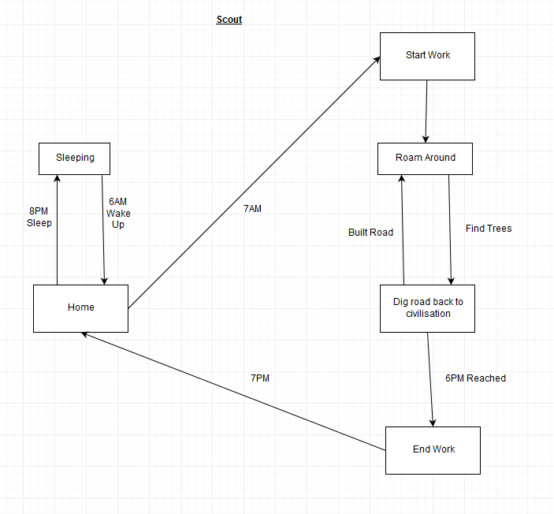

### 4.4.2. Path Layer

Path layers are different to a road layer in that they only build paths between houses. Paths are much straighter than roads too. There can only be one path layer per civilisation at any time as there is no use for more than one. Whenever a new house is built they immediately get to work in connected the house to the paths.

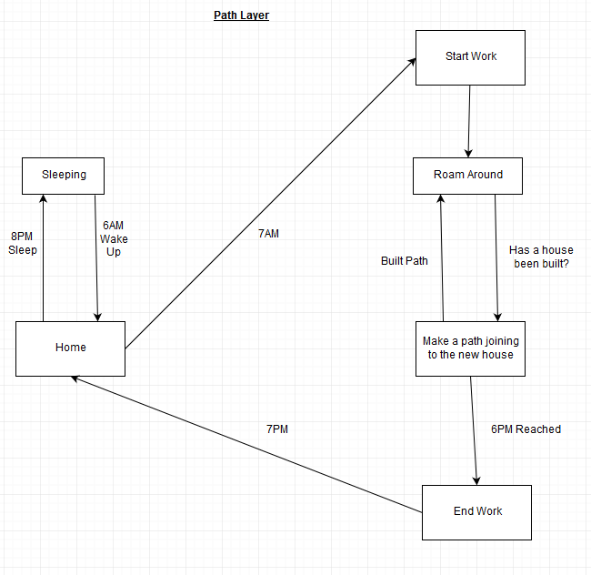

### 4.4.3. Gathering Jobs

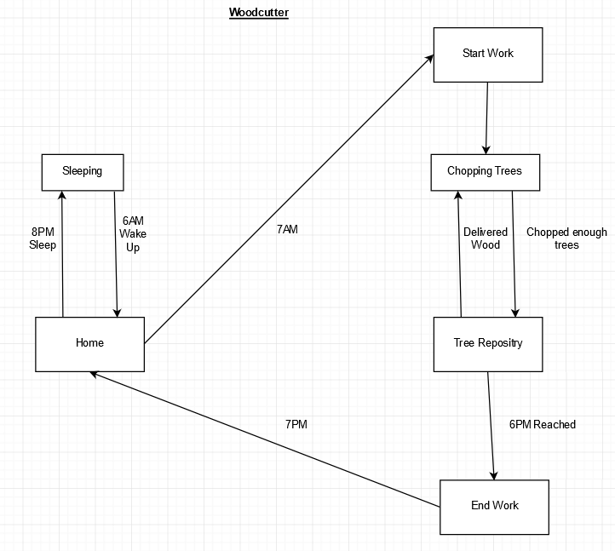Most A.I in the game will follow a simple daily routine. This can be represented using an A.I state machine. This is what a wood cutter’s daily activities include:

The above finite state machine shows that:

* A woodcutter wakes up at 6AM
* Starts work at 7PM
* When work commences, a loop is started where they will look for trees, chop them until they reach the limit of wood and drop them off at the tree repository.
* When it is 6PM work finishes, and they go home.
* When it is 8PM they go to sleep, where the cycle repeats.

To see the rest of the A.I state machines, they will be included in the appendix. The AI job types that are similar to woodcutters are all resource gatherers such as hunters, plant gatherers, farmers and miners. For example, a hunter will be mostly the same except instead of chopping trees they will be finding animals, killing them and delivering the meat at a food repository.

### 4.4.4. Farmer

Farmers are the most simple of the jobs in terms of behaviour. All farmers need to do is exist and they will produce food each day. This job is only available to civilisations above level one. Having farmers allows rapid growth since as civilisations aren’t reliant on hunter gatherers to get food.

### 4.4.5. Cut Jobs

There are some jobs that were cut due to them being unneeded or due to time constraints. These can be viewed in appendix B.

### 4.4.6. Animals and Plants

Animals and plants are spawned all over the map. Animals roam around while plants of course do not. Hunters need to chase animals down to hunt them. Plants on the other hand are much easier since they don’t need to be chased. Plants are also more abundant as there is a higher max value for what can be spawned at once. Plants give much less food when harvested however so hunting animals is worth it despite there being less and harder to catch.

## 4.5. Civilisation Design

### 4.5.1. Spawning

When the simulation starts the position of civilisations is picked at random so long as it is spawned on grass. Also when being spawned the civilisations name is generated by combining one word with another. This should make the names of each civilisation unique.

### 4.5.2. Layout

The civilisations should be designed in a way that looks somewhat natural. For example, as houses are built, and land expands it should not look like houses are just placed on a grid. There should be variance between spaces of houses while still looking tidy and uniform.

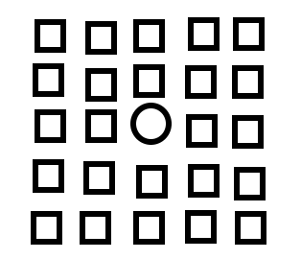

Figure Unnatural Town Layout

The above image shows what the civilisation should not look like. It is as if they have just been placed on a grid, too neatly and unnatural. These kinds of cities would only exist in the modern age which requires a city planner and such. For the civilisation simulation it needs to look like there were no plans, where people just decided to build houses.

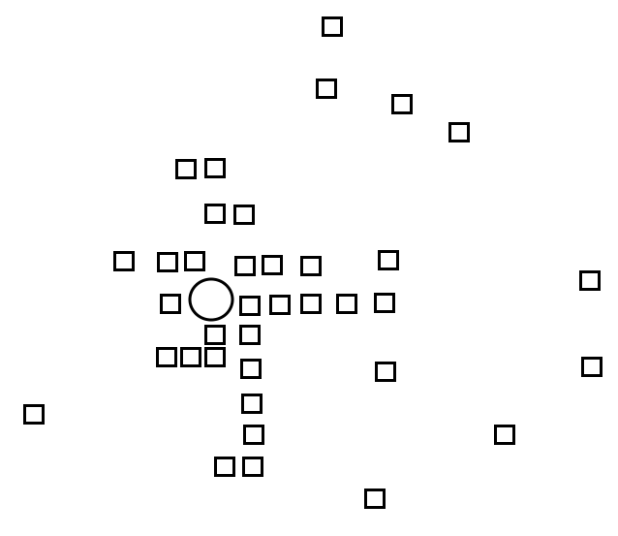

Figure More Natural Town Layout

The image above shows how the towns should be generated. The houses are placed uniformly, but there is an element of randomness to it. They are not just placed on a grid filling in the box next to it. There is still an identifiable central point and houses are spawned sparsely on the outskirts too. All of these elements work together to make it seem like a natural growing town.

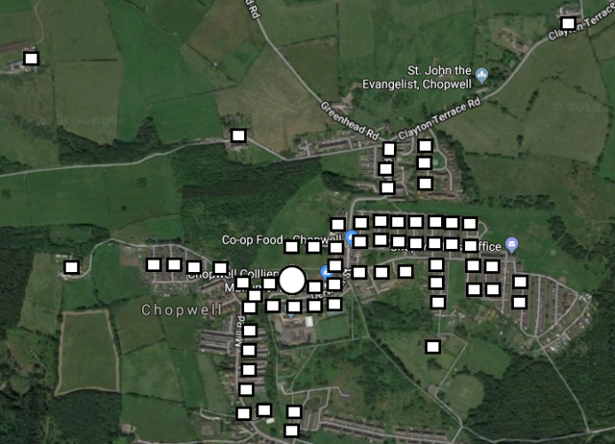

Figure Trace Over Real Town

To get an even better idea how towns should look in the game a random village was chosen on Google maps (this image shows Chopwell) and was then roughly traced in the style it would look in-game. As previously presumed there is a central area, a bit of build up around that then there is sprawl the goes further out with the furthest away being farms then there may be a few houses next to these farms. This is the exact design the towns will be generated to look like.

In the previous sections, roads and paths were talked about, these would connect houses and resource points which are areas where there are trees and rock nearby. In addition to this citizens build bridges if there is a body of water which is hard to cross. There can also only be a certain amount of roads in a designated circumference.

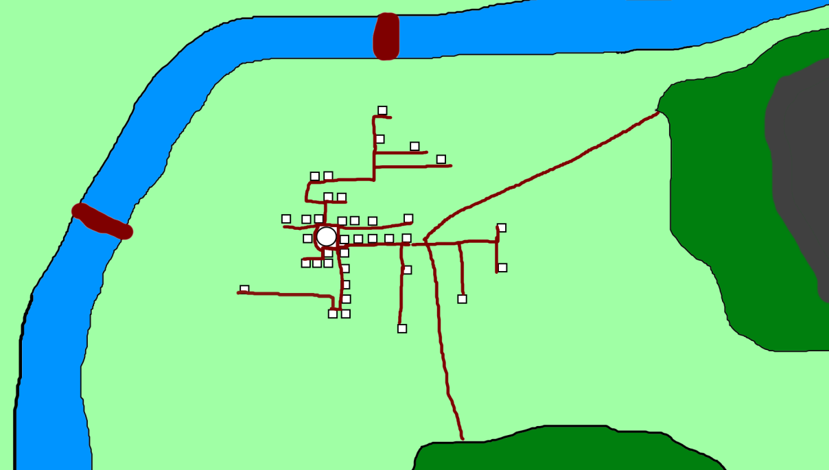

The above image is a drawing of what towns should look like with all these features in place

### 4.5.3. Resources and Levels

Civilisations hold the reserves of resources such as wood, stone and food. These reserves are important for the growth of civilisations. Wood is used to build the initial dwellings for citizens to live in and stone is used to upgrade these when a civilisation is past a certain level.

Food is a necessity for citizens to survive and grow. The civilisations food is shared by all the citizens. Every day each citizen takes a certain amount of food from the reserves. If there is not enough food left for individual citizens, they will lose health every hour until they have been fed. There also needs to be a certain amount of food to be in the reserves before children can be born. Therefore, not having food will inhibit the birth of new citizens meaning it will start to die out.

Civilisations have three levels. These are level 1(tribes), level 2(towns) and level 3 (Cities.) Level 1 tribes will only spawn tents and the middle of the city is simply a flag. Tribes cannot have farms, so they rely solely on hunter gatherers. Tribes are slow to grow due to this.

At level 2 the civilisation upgrades to towns. When a civilisation is at this level farms can now be built. This can make the civilisation more sustainable. Tents can also now be upgraded to houses with enough stone. At this stage the town will look more like a town than a settlement full of tents. The flag in the middle also becomes a proper building serving as the town centre.

The last level 3 will only be a cosmetic upgrade which allows houses to be upgraded again to bigger houses. The town hall in the middle will also look like a big castle. This level is like a way of letting the user know that the city is now massive and have reached its final level. The civilisation can continue to grow but there will be no more differences to architecture after this stage.

## 4.6. User Interface Designs

For the software to be useable to a user, it is important that the user interface is intuitive and easy to navigate. An overly complex interface will result in frustration and deter users from giving the software a chance. The intent of each button or slider should be immediately understandable and those that aren’t should be explained simply.

The first part of the user interface is the main menu. This serves as the main hub for which they will start the simulation, change settings, learn more about the software and quit the game. This is necessary to provide the user with a central menu to gain their initial bearings and to find settings that may be of use to them.

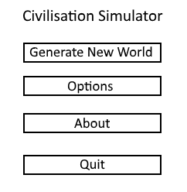  
The image above shows the main menu the user is greeted with. It is simple and to the point, the title is shown at the top to inform the player of the software they are using. Below this are clearly labelled buttons which bring the user to their corresponding menu.

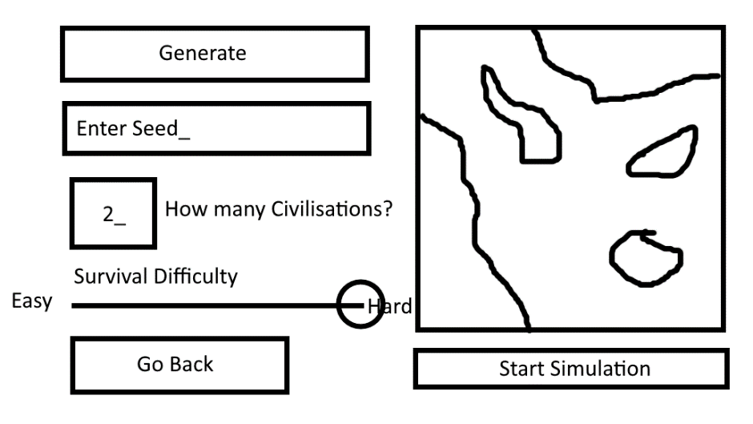

The image above shows the generate new world menu. The map to the right shows what the currently generated world looks like. The enter seed box allows you to type in a seed which is used by the world generation algorithm to generate the world. By entering the seed in another session the user can generate the same world.

The box which asks how many civilisations allows the user to type how many civilisations the world will start with.

The survival difficulty slider allows the user to move the handle either left or right. Each side is labelled easy and hard. Moving the handle to the labelled side will change the survival difficulty to that. It changes the difficulty for civilisation to thrive. Setting it harder will make gathering food worth less for example.

The go back buttons bring the user to the previous menu which is the main menu.

Once the user has input all their settings they can press the generate button which will save them. Pressing the start simulation button will start the simulation with all their settings.

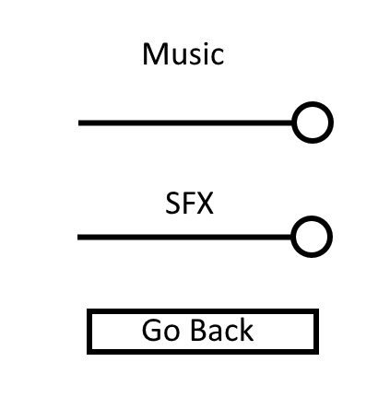

The above image shows the options menu. There are not many settings to change as software built with the unity engine includes a start configurator which enables you to change the graphics quality and resolution. Therefore, there does not need to be a setting for that in the options menu. Changing the volumes of sound is not included in the start configurator so they are available in this menu.

To change the volume of each sound the user would move the handle on the slider until they have the desired volume. The go back buttons brings the user back to the main menu.

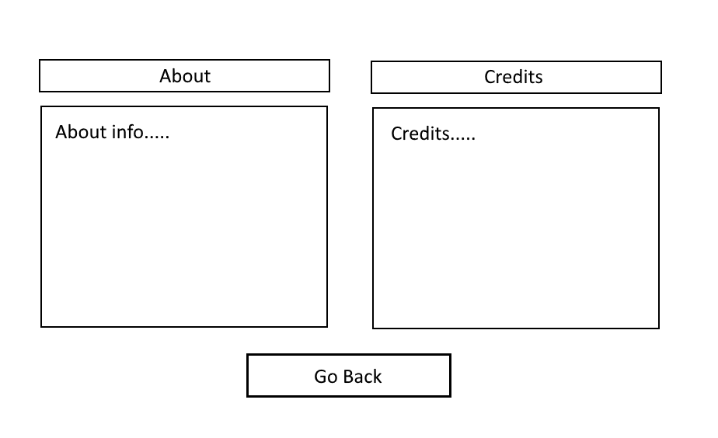

The image above shows the about menu, this includes two boxes. The first box is information about the project, why it was created and how to play the game. The second box has all the credits for the game such as who created the royalty free sprites, sound and music.

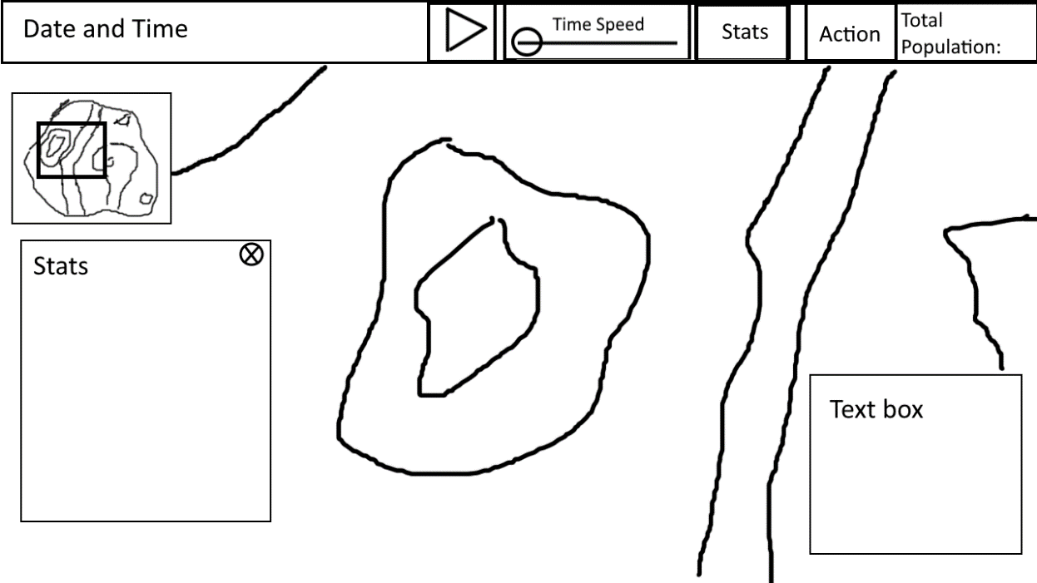

The above image shows how the user interface in-game will look. First of all there is a bar at the top where all the buttons are located. This allows it to be organised and out of the way. It will also be slightly transparent so that it doesn’t annoy the user if they want to see behind it. On this bar there is first the date and time displayed to the left. This is a good place to put it as eyes are easily drawn to this part of the screen.

To the right of this is a pause/play button. This allows the user to start and stop time, an important requirement for the project. This is placed strategically next to the time speed slider. This is due to the fact they are related as these both control time.

The time speed slider allows the user to move the slider back and forth to increase or decrease time. The further left the slower the further right the faster. A slider is good for this since it doesn’t require much explanation and is easy to grasp what is going on when changing the position of the slider.

To the right of this is two more buttons which are related. These are the stats and action button. These buttons change what appears in a box at the bottom left. The stats shows the user information on selected objects in the world and the action button brings up buttons which the user can press to perform specific actions. The box which these appear in can be removed from the screen by pressing the x at the top right of the box. This is an important feature as the user may not want the box on their screen at all times and so allows them to see what is below it.

Next to the stats and action button it shows the total population of the world. Just like having the time on the top left, the total population at the top right seems like a good place to put this important information and also in a position easily seen by the user.

Underneath the bar is a minimap, this shows the whole map no matter what zoom level the player is at. It is inside a small square out the way and is not intrusive to the user as they use the simulation. Also inside the minimap is a small square which represents the camera relative to the map. This is very useful in determining where you are as being zoomed in far can be disorienting and would easily lose where you are without it.

In the bottom right is a text box. This tells the user of important events which have taken place in the simulation. These can be things such as when a child is born, when someone has got married, and if someone has died and by which cause. Without these events being reported it would be very hard to observe these taking place so this is a good way in letting the user know.

## 4.7. Passage of Time

Designing how time would pass was a surprisingly hard task. This was designed and implemented at the same time so you can read about this in Appendix F.

# 5. Implementation

## 5.1. Requirements Changes

*Requirement 20: Zoom in and zoom out buttons which allows you to get a closer or further away view. Using the mouse wheel does the same thing.*

It was decided there would be no point to include buttons to zoom in and out when the mouse wheel is already much more convenient. Given the ability to zoom in using the mouse wheel, users would not bother to press buttons.

*Requirement 22: A fast-forward button along with a multiplier showing how many times faster the time is currently at.*

Instead of using a button, a slider was created to do this job. This is a lot better and easier to use than a button. This is because you can visualise the speed just by looking at how far along the slider is. It also means there doesn’t need to be a multiplier to show how many times faster the speed is.

*Requirement 22: The world is randomly generated with textured tiles depending on the terrain.*

Tiles were decided to be textured, single coloured pixels. This is to save on performance and time. Single coloured terrain works well as it is so programming them to use textures isn’t going to be much benefit.

*Requirement 28: Disasters can occur*

Although having natural disasters would be an excellent addition to the game, as it would show citizens adapt and react around them, there simply isn’t enough time to implement it within the timeframe. Although it would have been a good feature, it is not a must have as there is already a lot to show citizens adapting to the generated conditions around them such as finding stone and wood, building on hospitable land and avoiding water. It was a hard decision but it was necessary.

*Requirement 47: There are miscellaneous jobs which don’t have an unusual daily routine which usually just consists of going to a building then going home. These would be jobs like teacher*

Originally it was planned there would be many different jobs that don’t really contribute the growth of a civilisation. This was to make the simulation seem more real. However this is feature has a priority rating of could be and therefore was scrapped due to time constraints.

*All requirements related to sound that isn’t music*

All sounds were deemed low priority and since there was low time, adding sounds except music had to be cut.

## 5.2. Creating And Solving Problems

### 5.2.1. Programming the terrain generation

Before working on the AI, terrain generation needed to be completed, so as such this is the first thing that was worked on. It is quite complicated but a break down of the code and how it works is located at appendix G.

## 5.2.2. Improving the terrain generation

Generating the map without changing any of the values will not get terrain with the desired results. Therefore, many tests will need to be made to get the perfect island for the game. These are the sort of tests that would need to be made to find the right island:

Values in red have been decreased since the previous generation.

Values in green have been increased since the previous generation.

**Test 1:**

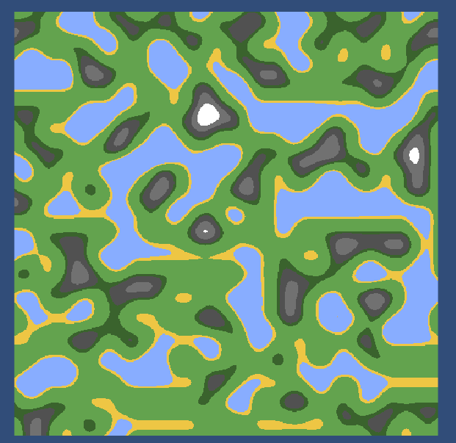The values for this generation are:

Map Width: 500

Map Height: 500

Noise Scale: 50

Octaves: 5

Persistence: 0

Lacunarity: 0

Seed: 486

This map is not suitable for the game as there are too many small long islands. It is not very appealing to look at either. The shapes of the island are also very smooth. For the next test, I will increase the noise scale so that there are fewer and bigger islands.

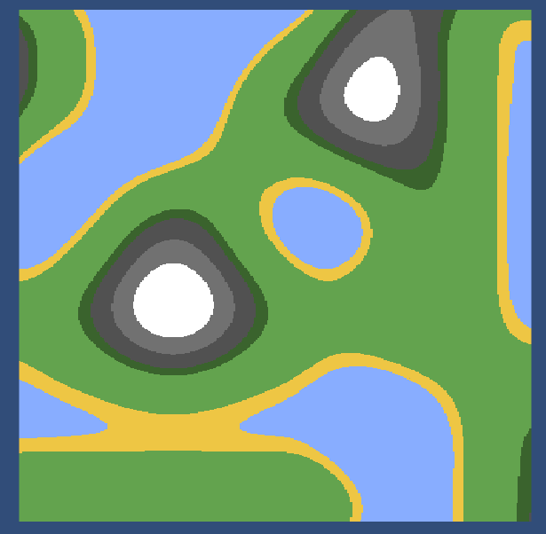**Test 2:**

The values for this generation are:

Map Width: 500

Map Height: 500

Noise Scale: 200

Octaves: 5

Persistence: 0

Lacunarity: 0

Seed: 486

The scale is a lot better. However, it doesn’t look much like an island as it looks more like splodges of paint. Next persistence and lacunarity will be altered

**Test 3:**

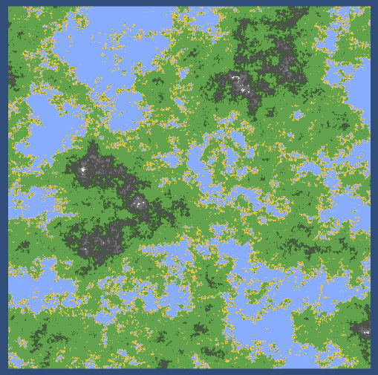The values for this generation are:

Map Width: 500

Map Height: 500

Noise Scale: 200

Octaves: 5

Persistence: 0.685

Lacunarity: 3.57

Seed: 486

This generation is a lot less smooth than the previous generations. However, it is a lot more fragmented and detailed than needed. The scale is also too small so when you zoom in the land covers too few pixels. For the next generation, the persistence and lacunarity will be weakened. The noise scale will also be increased slightly

**Test 4:**

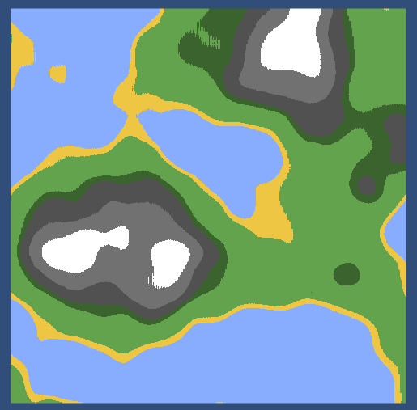The values for this generation are:

Map Width: 500

Map Height: 500

Noise Scale: 240

Octaves: 5

Persistence: 0.553

Lacunarity: 1.5

Seed: 486

This generation is much less detailed but much more suitable for the game. There is a lot of space for the civilisations to move around through and there is a range of different terrain types for them to survive. Next, I will need to test to see if most the islands these variables generate are suitable for the game.

**Test 5 Check if all generations are suitable:**

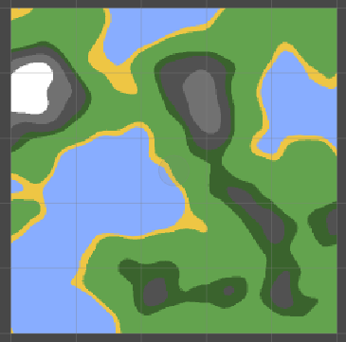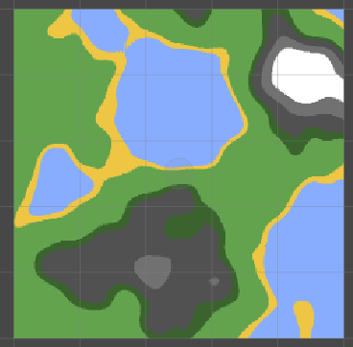

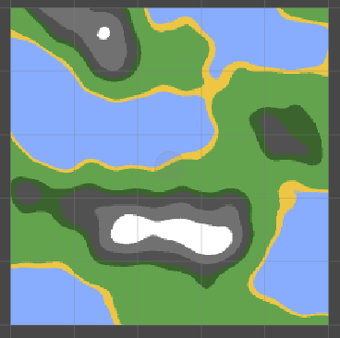

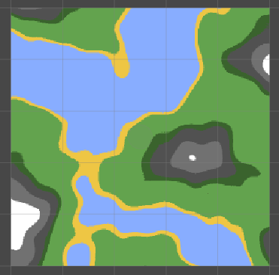

Here are some examples of the island being generated with different seeds. As you can see from the examples, they will all be suitable for the game as they generate with everything that is required. They all provide a lot of space for civilisations to thrive and have good island shapes.

### 5.2.3. Citizen Movements

Implementing the way citizens move around the map was implemented in two different ways because the first method was not satisfactory. The first method that was implemented was extremely simple and caused a lot of problems due to how simple it was.

All the first method did was increase the transform by a specified amount in whichever direction. It simply did this by adding a vector to the transform each frame. There was no use of speed, acceleration or velocity. Due to this it was very limiting in what could be done.

When trying to implement steering algorithms it became apparent that this original method would not work as no calculations could be made on it’s direction and speed. For the second method it uses three variables; the transform, the acceleration and the velocity.

When a function needs to move a citizen in a certain direction instead of adding this to the transform straight away it will add it to the acceleration. After all the transforms have been added to the acceleration the acceleration is made sure it doesn’t go above a max value by multiplying the normalised acceleration to the maximum acceleration.

// Clamp acceleration to maximum

if (m_Acceleration.magnitude > MAXIMUMACCELERATION)

{

m_Acceleration = m_Acceleration.normalized * MAXIMUMACCELERATION;

}

The velocity is then increased by the value of the acceleration. The velocity is then clamped to max speed so that they can’t go faster than a certain value.

if (m_Velocity.magnitude > MAXSPEED)

{

m_Velocity = m_Velocity.normalized * MAXSPEED;

}

Finally the transform is increased by the velocity which is multiplied by delta time so that speed is consistent no matter how slow a computer is. The acceleration is then reset to 0 so that it can be looped over all again the next frame.

transform.position += m_Velocity * Time.deltaTime;

m_Acceleration = new Vector3(0, 0, 0);

The reason this works well is because acceleration is the change of velocity over time. Therefore, calculations can be done on the acceleration which makes only gradual changes in the velocity.

### 5.2.4. Steering Algorithms

As talked about by (Bevilacqua, 2012) steering algorithms are a way to get autonomous characters to move realistically by using simple forces which all combine to create improvisational navigation around the environment. These steering algorithms do not use any kind of complex strategies involving path planning but use local information like the forces surrounding the character.

This sounded like a great way to make the citizens avoid areas such as bodies of water and mountains by using a wall avoid algorithm, this is due to the fact there would be no need to use pathfinding. Using this in combination with having a citizen walk towards a target should result in them walking around it.

This was achieved by having four sensors surrounding a citizen in four directions. When one of the sensors locations collides with a water or mountain it will report the location of the sensor relative to the position of the citizen. This will be normalised to get the vector as a unit vector which is the direction away from the collision.

Vector3((transform.position - myCircleBound.sensorLocationCollision()).normalized.x, (transform.position - myCircleBound.sensorLocationCollision()).normalized.y, 0);

The avoid wall function returns this value so that it can be used in calculations to be applied to the velocity. It is used when a citizen is told to go towards a certain position by the GoTowardsPosition function.

It does this by getting the direction towards the target and storing that in the desired velocity. The Citizens acceleration then becomes equal to this desired velocity minus the current velocity. The current acceleration is then increased by the square magnitude of the velocity multipied by the avoid wall algorithm.

Vector3 desiredVelocity = (targetPosition - transform.position).normalized * 100.0f;

m_Acceleration = (desiredVelocity - m_Velocity);

m_Acceleration += m_Velocity.sqrMagnitude * AvoidWall();

With all these working together it will result in citizens heading towards their desired location whilst being pushed away from the collision.

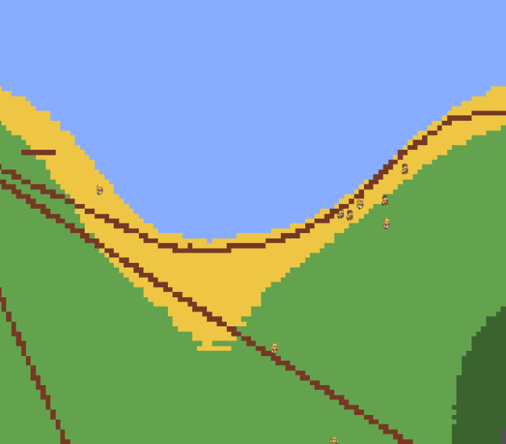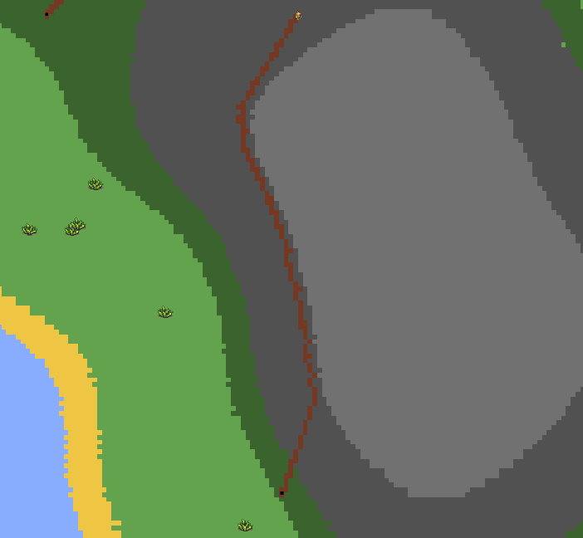

Figure Path Laying Citizen Avoiding Water

Figure Path Laying Citizen using the avoid wall algorithm

[h](https://gamedevelopment.tutsplus.com/series/understanding-steering-behaviors--gamedev-12732)

### 5.2.5. Bridges

One issue that was run into is that it would be common for citizens to get stuck behind collidable areas if they were steep very steep. This is due to the fact citizens rely solely on the wall avoid steering algorithms to get around them. A common way to get around this issue would be to implement A* pathfinding but due to time constraints it was decided to not program this in.

The solution was simple, have citizens build bridges when they are stuck. Not only would this fix the issue but it was a feature talked about before and would and would show how the citizens adapt and change their environment.

Bridge building works by checking if a citizen has touched water. If they have it would start a coroutine where it will sample, its location. It would then wait 10 seconds and sample the location again. If the two locations are close together then it is determined that the citizen is stuck. After this point the citizen will begin building the bridge to the other side. If the citizen has hit land, then bridge building will end.

After this, another issue arose. No matter if a bridge had already been built citizens would make another bridge. This created a mess of bridges as seen in (Figure 2.)

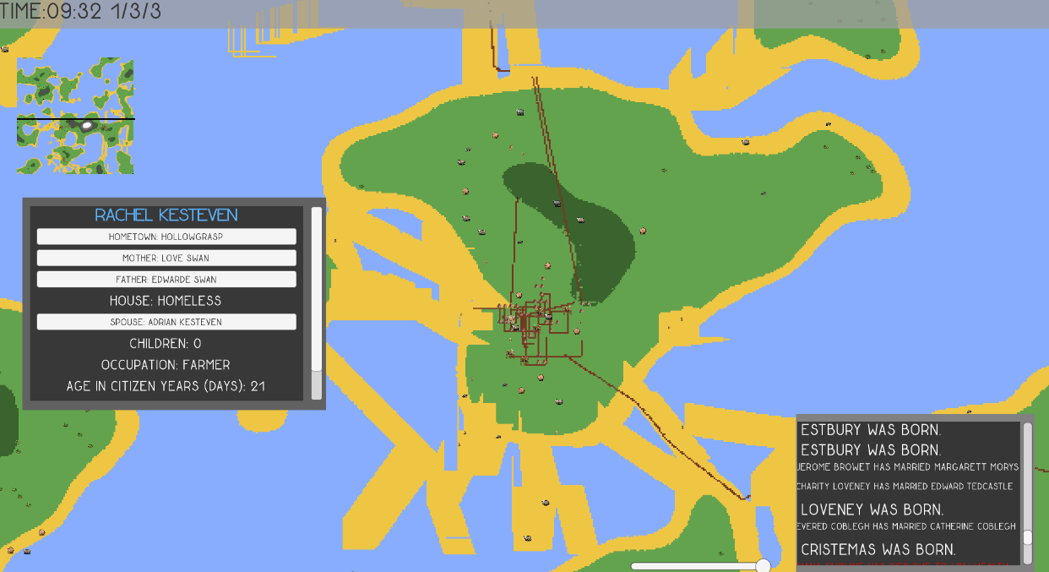

Figure Mess of Bridges (At this point bridges were the colour of sand)

To fix this, the program checks to see if there has been a bridge built within a certain radius. If there isn’t the citizen will build the bridge as normal. If there is the citizen not build a bridge but go to the entrance of the bridge and follow the bridge along to the exit. This solves the problem not only for the first citizen to get across the water but for any other citizen that wants to get across as they can use the bridge.

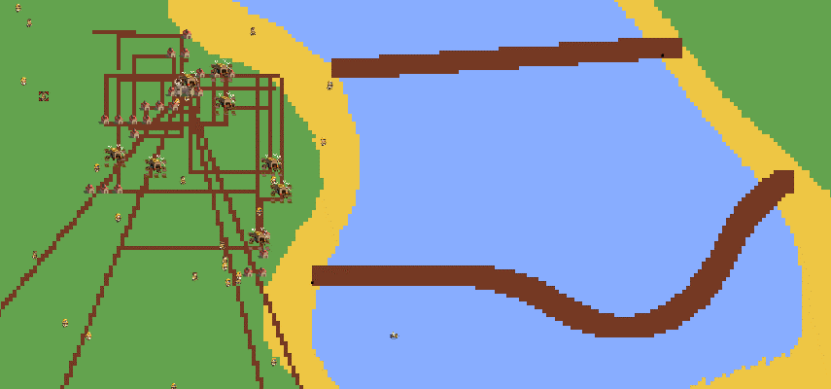

Figure Bridges which aren't as messy

### 5.2.6. Sensing and changing the terrain types

Implementing the ability for terrain types to be sensed and changed included many problems that was needed to be overcome. The generated map was designed in such a way that each colour is a different kind of terrain. These colours are added to a one-dimensional colour array which has a designated map width and map height. It might seem difficult to represent each pixel in an array that only has one dimension but it’s quite easy.

Pixels are set or got from the array using the formula of yValue * mapWidth + xValue. The generated map in the game has a map width of 1280 so imagine the whole of the bottom row is from 0 to 1280. So what if we want to access a colour on the second row? Well as the bottom most row is a y value of 0 the second row is a y value of 1. So, the starting point of the second row is 1280 which goes all the way to 2560. Basically, every row is an increment of 1280. That is why multiplying the y value by map width will get which row it is on and why adding an x value to this number will get how far along the row it is.

It’s a simple concept however this was not immediately clear to me, but once I understood the formula I knew exactly how to access the positions of each colour.

Once all these colours were set at the start using the terrain generation algorithms, the question was what was the best way in accessing these colours with minimal performance impact. The first method I used was not very good and had massive performance impacts. Whenever a pixel was set or checked mid game the performance would fall below ten frames a second.

This was the method I used, instead of accessing the colour straight from the colour array, I would access the colours from the texture that was created using the colour array. Accessing a big file like a texture multiple times a second was of course going to give a giant performance hit. Not only was this giant file being accessed but I was telling the program to find specific pixels on the texture. Worse still when I was setting a pixel it would have to go into the texture and regenerate it all over again.

This was terrible for performance, so when I realised my mistake, I instead access the pixel straight from the colour map. That part was fixed however actually setting a pixel was still a predicament that was needed to be solved. If I wanted to change a pixel of the terrain I would still need to regenerate the texture all over again multiple times a second.

It was figured, the best way to do this was to set the colour in the texture array and instead of regenerating the whole image again I would only generate that small area of pixels on top of the texture. This sped up the setting of pixels dramatically and seemed to fix the issue.

**Changing Multiple Pixels At Once**

After implementing bridge building there was a noticeable performance hit. Every time a citizen built a bridge the game would slow down dramatically. This was due to the fact bridges were thicker than normal paths so more than one pixel was being set each frame. Originally the method would go through a for loop and call set pixel each iteration.

The solution was to not does this through a for loop but to create a new colourmap of specified size by the user. The for loop would set all the colours of this colour map. And then after this new colour map was filled it would call a different function “SetPixel(s)” instead of “SetPixel.”

In SetPixels you can set many pixels at once with much less of a performance hit. The colour map is passed into the function and that was it. The performance got much faster as citizens build bridges.

### 5.2.7. Spawning Houses

Spawning houses was a challenge to program, in order to get it to look like Figure 3. In order to look as though it does in the image the first step was to get it to spawn randomly and not fill in a grid.

The first iteration of the house spawning did not follow any rules and resembled random chaos. When a house was spawned there could be four positions where the next could spawn. Each of these sensors are added to a list and picked at random. This was a problem because the house could spawn again at the same position making it a mess to look at.

To fix this each sensor was giving a Boolean called working. If working was turned on a house could be spawned on it, if not a house could not spawn. To work out if a sensor was working or not it would check for collisions with other houses. If the censor had collided with another the working Boolean turned off. This worked very well and started to look much more natural.

It did not look exactly like Figure 3 yet as there was quite a congregation round the middle but did not have houses sprawl further away from the centre. The solution came when farms were implemented. Farms were another building type that would not just spawn on a sensor like other houses. It would be spawn on a house sensor but then in a random distance away from it.

Houses could then be spawned at any of the sensors around the farms. Since farms were spawned at possible further distances it would emulate the sprawl further away from the central area of towns. This was the exact result which was wanted from the random layout of towns.

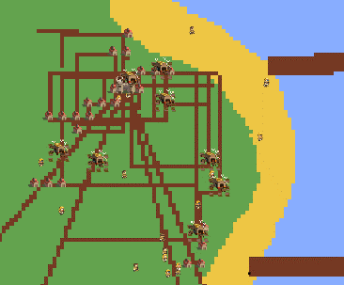

Figure Houses Congregate in the middle while farms and more houses sprawl further out

### 5.2.8. Targets

Many jobs for the citizens need to have a target which they must walk towards. For example, hunters need to be targeting an animal or wood cutters need to target a resource point to begin wood cutting. How a target was chosen depended on the job.

Wood cutters and miners chose their target by randomly selecting a new resource point, in the civilisations list of resource points each morning. This was simple and had no issues. Targeting animals and plants was a little more complex as it was needed for no animal or plant should be targeted by the same citizen at once.

In the first iteration of this feature it was possible for multiple citizens to be targeting the same thing. The animal or plant to be targeted at was simply the closest to the citizen. This caused many citizens to flock towards the same target at once. This was not good for civilisations as it was not an efficient way of hunting and made no sense.

If citizens targeted different animals and plants they could yield much more food quicker than wasting time with most following the same target. It would be common for large civilisations to die out due to not getting enough food quick enough.

To fix this as well as a citizen looking through the list of possible targets and choosing the closest one, there would a variable in the target which was which citizen was targeting it. So now a citizen would have to also make sure that the target had nothing targeting it before being selected.

### 5.2.9. Flow Implementation

The flow of the simulation is how the average user will experience the simulation. One activities should take place. You can see what this looks like in appendix H.

### 5.2.10. Interacting With The World

As the user there needed to be a way to select objects using the mouse. Two methods were attempted to achieve this. The first method was to use what is called a world canvas. In unity a canvas parses the mouse’s position and is used to create UI. The idea was that each citizen would have a corresponding button on the world canvas. This caused issues you cannot use more than one canvas at once. There was already a canvas in use which was used for the user interface. It would have been bad for performance too having to spawn an additional object on the world canvas layer.

The second method was to use a raycast. A ray cast is basically a line which is transmitted from a specified position. If an object collides with this line then it will return the object that was hit. This was the line used to do this:

RaycastHit2D hit = Physics2D.Raycast(Camera.main.ScreenToWorldPoint(Input.mousePosition), Vector2.zero, 100, clickableLayers);

It took a while to figure out exactly how to get this working. Initially when trying this it would not bring any results. This was due to the fact any object that needed to be clickable had to have a collision box. All necessary objects were given collision box’s and the raycast was tried again. This time it would work however sometimes some object just wouldn’t select.

It turned out that the sensors of houses would cover up other objects since they also had collisions. The solution to this was to use layers. Each object can be given their own layer, for example a citizen layer was created for citizens, and a sensor layer was given to senses.

Then a list of all layers that can be clickable by the raycast was created. Finally things in the world could be clicked on as intended.

### 5.2.11. Citizen Management

**Endless Farms**

There were many issues with the management of citizens throughout the project. The first issue happened when a citizen would die they were not properly be deleted from their house This caused an issue where there would be too many houses with dead people living in them. This would cause towns to become abnormally large when a citizen could have simply moved to the house of a dead citizen. This was fixed simply by removing citizens from the resident list of a house when they died.

Another issue arose where when citizens were dying the town would be overrun by farms. They would keep spawning endlessly.

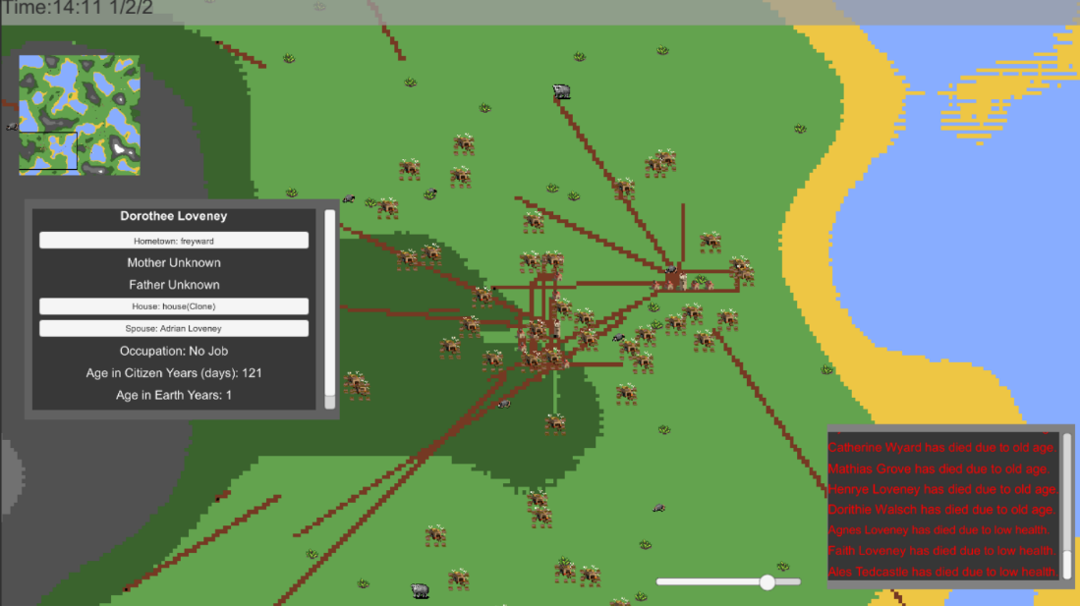

Figure Endless Spawning Of Farms When Citizens Died

This error took a while to debug and get to the bottom of. It turned out that it was down to a silly mistake. Originally farm houses would only spawn if the number of farmers did not equal the amount of farm houses. This worked as if there was one farmer, one farm house would spawn.

As the amount of farmers increased another would too. However, if a farmer died, this would trigger the function and would keep spawning farms endlessly as the amount of farms would never equal the amount of farmers as the farm count was now above the farmers count.

This was an extremely simple error to fix. Just use: if (farmHouses < farmers) instead.

## 5.3. Testing

### 5.3.1. Internal Testing

In order to make sure all functions of the game work as expected a testing table was created. The table consists of a list of the most essential functions and the expected outcome from it. Next to this is if the function has passed or not. This table is located in the appendices.

### 5.3.2. External testing

**Introduction**

A questionnaire was produced to give to participants to receive feedback for the software. The nature of the questions being asked was to give observations and suggestions on improvements to be made. This is useful in order to improve the current software in areas which can easily go unnoticed by the author. As someone spends a lot of time programming they would not be playing it as someone completely blind to the product, which is why it is important. The questionnaire was ambiguous to get a broad range of answers.

**Participants understanding of the product without being told what it was**

Participants weren’t told exactly what the software was except that it was a world simulator. This was to test how well the software worked at communicating how it works without being told outside software.

All participants communicated that there weren’t any instructions, so they had to figure out what they were doing almost completely by themselves. One complained that it wasn’t clear which entities were clickable as they tried to click things like animals. It was suggested that there should be some form of tutorial or instructions in the game or something like key binds.

**What did they like about it?**

One thought being able to generate a map using words was a great idea and had fun just typing words into the input field. They also liked looking at the people go about their daily lives. Another liked being able to preview the world before starting the game as it gave them a good idea of what the world would look like. They also liked the clear cohesive aesthetic of the terrain. Another said they liked to change the timescale using a slider and liked the fact you can get an insight into their lives by clicking on them and reading their stats.

**What did they not like about it?**

The first participant would have liked it more if there was a way to interact more as for the most part it was only observation. A second participant thought there was no clear direction of what they were supposed to be doing. They also would have liked it if the animals were animated as they felt it looked weird that they were a static sprite moving around.

The third participant felt they easily lost track of villagers that they had previously clicked on and felt it was hard to check back on them when they had lost it.

**What did they think of the UI**

The first participant felt that the UI was ok and once they knew what they were doing there was no issues.

The second observed that scrolling even when the entity box was not selected made the world zoom in and out. It should only zoom while their mouse was hovered over the terrain. As at the time many important buttons were not implemented it was not possible to go back to the menu . They liked the bar across the top of the screen and was laid out clearly and so knew exactly what each button should do. They however thought it wasn’t clear that they needed to press the generate button in order for their world to be generated.

The third participant thought the menu was confusing. They didn’t like that the text box at the bottom had variable font sizes, not united in one size. They said this made it hard to read. They also wanted the scroll box to return to the top when they had came back from another scroll box. They wanted a feature for a back button to allow them to go back to the previous selection. They thought the main menu was simplistic and clean. With a good clear preview of the map. They liked being able to input the seed into the box and generating it with the clearly labelled buttons. In game they also liked the time at the top. They thought it would be good to move the selection boxes around.

**What do they think of the controls?**

The first participant felt they needed instructions to understand how the controls worked. They also wanted to have a setting to change the speed of the navigation. They first didn’t realise they needed to use the keyboard to move around and first tried to move only by dragging the mouse.

The second participant also tried to move around using the mouse. They thought there should be something to tell you how to control the game. They suggested there should be a way to change the control style from keyboard to click and drag. They also didn’t think you should be able to move the camera so far that it is no longer on the map.

The third participant also thought the WASD keys shouldn’t move the UI. They suggested that you shouldn’t be able to move the camera when selected or simply remove the ability to control sliders using the keyboard.

**What they liked and disliked about the AI**

The first participant felt that the AI almost felt like real life in the sense they were building, expanding, growing and living. They thought it would be cool if you could drop something into the world and have them react to it.

The second didn’t like that the AI would build massive sand bars across seas which was a glitch at this point in development.

The third also observed that bridges were built in places that didn’t make sense and as time went by they would be built in weird shapes. When animals die they didn’t disappear and would just stop moving which they didn’t like either. They liked that people would return to their houses during the night. They were not keep on the shapes of roads compared to paths between houses. Paths between houses were squarer shaped while roads were less so.

**What they liked and disliked about the designs**

One participant felt the design fit the purpose. The second thought the boxes were quite boring and would rather they have a nicer more colourful border. They also thought the buttons on the menu were boring. They did like the background in the menu but thought it could be improved if the background moved or changed.

Another participant liked the vivid colours, art style and simplistic menu which was clean and too the point. They felt it would be better if people and animals were animated. They also thought it would be good if when people decide to move in a certain direction they would rotate that way.

**Bug Observations**

One participant noticed that the preview map was mirrored to the map when they start the game. The target reticule was offset incorrectly on entities which non-citizens were. A strange black bar would also appear if they were zoomed in too far.

Another participant observed that the camera can go past view bounds and went upside down when zooming in. Dead people also didn’t get removed at this time and citizens would glitch through walls when there was a lot of lag.

**Performance**

One participant noticed there was a lot of lag when the speed slider was set to full. They thought the game took a little too long to load. They also thought it might be a good idea to make the preview map less detailed to speed it up further.

The next noted there was a lot of lag too which increased the longer the simulation ran.

**Conclusion**

All the feedback received from the testers was noted and used to make improvements where possible. All in all, the feedback received was helpful in showing issues that wouldn’t have been noticed otherwise and helps to determine the priority of things to be fixed.

# 6. Evaluation, Conclusion and Recommendation

## 6.1 Introduction

To assess the whole project an evaluation, conclusion and recommendation is created. An evaluation allows you to see how the project went, if it met the goals, skills that were learned and anything that could have been done better.

## 6.2 Evaluation

### 6.2.1. Product

**Focus Changes Since TOR**

Throughout the implementation stage of the project it became apparent that many features thought to be a focus, became more side-line. Though the main objective remains which is to create a sandbox game which simulates the development of civilizations as they adapt and react to the generated conditions around them.

In the TOR it mentioned being able to change weather conditions and placing monsters to see how civilisations react. This was not implemented in the final game as these were cut due to not being a big focus and would require a lot of time to implement.

The main focus of the game was to have citizens adapt and react to the generated conditions around them. Though originally there was to be emphasis on the world changing, this was also something talked about in the TOR. Now the focus is how the world changes due to the citizens rather than a changing world affecting the citizens.

There was also to going to be interactions between civilisations with them starting wars and even having eco-systems. Within the designated time frame including this along with everything else would have been very difficult.

**Ensuring Build Quality and Fitness for Purpose**

During the implementation phase of the project testers were asked to play the simulation so that feedback could be used to improve the product. This was done in an attempt to ensure the product was of great build quality and that it achieved its purpose. Feedback was used to improve upon bugs and ensure everything was understandable from a user’s perspective. The testers were encouraged to give feedback on improvements and of any errors that were encountered.

This was very effective as many things that were never noticed without the input of others were pointed out. It also helped as if a user could not understand something it would mean that there may be something wrong in how a particular feature was being implemented.

In addition, a requirements list was created to refer back to during development so that focus was not lost to unimportant features. Each requirement was also given a level of importance so that if deemed necessary the least important features could be cut due to time constraints.

This was definitely an effective method as many times focus would drift into trying to get something inconsequential running smoothly then when checking back to the requirements list it would help get past this and get back to more important features.

Testing the product internally was also used to make sure functions worked as intended. Test would be carried out and if one failed it would need to be evaluated critically to figure out why this was.

### 6.2.2. Process

The TOR lists all the objectives for the project, so these will be looked at to decide if they have been met.

1. **To create a literature review - research past games, AI, procedural algorithms and world simulation.**

A literature review was created in the analysis section of the project. The title of this literature review is *“Procedural Content Generation Algorithms: Generating a suitable world in which A.I. can develop, adapt and react on.”*

The purpose of this literature review was to find an appropriate terrain generation algorithm for the project that is most suitable for the job. It also looks into which would be the best for AI to interact with. The literature also investigates past games which use similar world simulation methods and how they go about approaching this and if there is anything that can be learned from them to use on the project. This objective was met as the literature review included all the topics listed in the TOR.

1. **To select the right tools for the project and methods of approaching it.**

A section called “Tools and Justifications” was created in the analysis section of the report. It looked at all the different tools that would be needed and compared them to find which would be most suitable for the project based on which is best for certain tasks and methods. Particular tools looked at were tools used for the designing of the simulation such as draw.io for diagrams, software used to implement the simulation such as Unity as the engine to create it. This section has met the objective due to this.

1. **To establish the functional and non-functional requirements for the project.**

A list of requirements was added to the appendices in the form of a requirements table. Each requirement has a category and a justification as well as a priority rating to determine how important it is. Non-function requirements are talked about in the requirements section of the analysis. Due to this the objective has been met.

1. **To design the project such as mechanics, gameplay, graphics, AI and terrain generation algorithms.**

In the synthesis section of the project designs were talked about extensively. These went over the many mechanics, how the simulation plays, the design of graphics such as UI, the AI such as all the jobs of citizens. How the terrain should be designed is discussed in the literature review. This objective has been met as all the design elements have been talked about.

1. **To begin development of the game, using the selected engine.**

The game was developed throughout the implementation stage with many aspects of its development documented inside the implementation section including how many issues were fixed throughout development. The projects code is also included in the appendices. This objective has been met due to this.

1. **To create a set of test plans and collect test results.**

Throughout the project two tests had taken place. Internal and external testing, a set of test plans were created for the internal testing where each function was tested methodically to make sure everything worked as intended. For external testing, participants were asked to play the simulation and were asked questions. The results from these tests were then collected. This objective has been met.

1. **To evaluate the product.**

This is in the product section of evaluation. It looks at how the focus changed slightly since the TOR and looks if the simulation is of adequate build quality and that it is fit for purpose.The objective has been met.

1. **To evaluate the process of the project.**

That is this current section. It looks at all the objectives which were supposed to have been met through the process of the project and determines if they have been met. It also looks at skills that were learned throughout the process and evaluates the time management aspects of the project. This objective was met.

1. **To write a detailed conclusion and add recommendations for the project.**

This is the final section of the project, it appraises whether the projects aims and objectives have been met. ---write after finishing

**Skill Development**

Throughout the project existing skills were utilized to help get through the project. In addition, skills were also gained in order to program certain concepts and use tools that were not used before.

One skill that was gained was using Microsoft Word more efficiently. This was surprising since word was used numerous times with other projects but there were many features of word that had not been used before. These were features such as automatic content page updating, adding references through word, adding figures which automatically update the numbers and more. These work together to make writing the project more efficient since it automatically updates things that would normally have to be manually edited in.

Another skill learned was programming in C# for Unity. C++ has been used before which contributed to the fast learning of C#. C# is very similar to C++ in many ways though using the Unity libraries had to be learned from scratch with the help of the Unity documentation. This included concepts such as instantiating game objects, ray casting and coroutines.

Some concepts that were learned were how Perlin noise works and generating a map using this.

**Time Management**

A Gantt chart was created in Microsoft Project to manage time. This listed all the milestones of the project, how long it should take for each one and the dates each one should start and end. It can be found inside the TOR. The milestones towards the beginning were quite easy to meet. The Gantt was referred to regularly to make sure targets were being met. In addition, an elog book will filled after every meeting with the supervisor. These two systems worked quite nicely in keeping track of all the work that was being completed and if the milestones were being achieved on target.

However, writing the Gantt did not keep in mind other projects from different modules. So as more projects were taking place, it became harder to meet goals. Not only that but when it came to the synthesis section the estimation of how long it would take was completely off by quite a bit. So, the further in to the year the less time would be managed as according to the Gantt.

In the end the estimates were a little too rough and some milestones such as the evaluation should have been shortened slightly while moving the synthesis along a bit and giving more time to the building.

It did not cause any issues however but would have if the project had many people involved. The Gantt also made sure that the project would be finished way ahead of time so going over wasn’t much of a problem at all.

Due to time constraints code was not commented as well I wanted. A lot of it does not adhere to good code standards. However much of the code related to map generation is well commented and has better code standards.

The report was also rushed quite a bit, so there will be mistakes due to not reading through it.

## 6.3 Project Conclusion

The aim of the project was to create a sandbox game which simulates the development of civilizations as they adapt and react to the generated conditions around them. This goal has definitely been met.

The product was successful in showing a civilisation adapt and react to a generated terrain and shows them making a big impact on the world in terms of what they build, and their environmental impact as animals and plants are lessened where civilisations are built. It also shows how the environment effects the civilisations as areas with less wood for example would slow down building.

A suitable terrain generation algorithm was chosen that would allow for easy interactability with the citizens and one that is quick and understandable to users. This was a great success as it generated all of the terrain types; grass, water, mountain, forest, stone and was suitable for a world where a civilization could thrive on.

Results show that simple job-based AI can work together to create a civilisation where one would not be able to thrive. It is a must that they work together to survive.

Some observations showed that civilisations would grow very slowly would then exponentially increase as more and more citizens were born. During the tribal stage it was much slower due to there not being any farmers but when civilisations grew to the next stage civilisations could support themselves through farms, even if there was no food for hunters and gatherers to take.

The simulation also showed realistic house sprawling where houses would be built up more in the middle and further out would be sparser with a few houses clumped together further out.

The simulation shows many parallels with a real developing nation such as the need for an equilibrium of resources and births and how small changes to environment can have large effects on the development. All in all it was a success.

## 6.4 Project Recommendations

There are many things that could be implemented in the future or things missed off throughout development due to time constraints. Firstly, code quality was not up to standards that would have been liked. So, if work was to be continued there would be a lot more comments and separation of many classes into more functions. Some pieces of code were shoehorned into other classes too, so these should be separated.

Not all sounds effects were implemented that would have been good such as being able to hear the sounds of the citizens doing their job when zooming in. Adding minute details like this would help draw the user in more.

The amount of new features that could be expanded upon are endless. These include more intractability, having natural disasters such as volcanos and tsunamis and having more communication between AI such as having wars with each other and establishing trade routes.

Adding more and more features will contribute towards it being more realistic and complex and has potential to expand even further. Natural disasters would be good as it will give the AI more chance to react and show their ability to adapt.

There could be aesthetic improvements too such as animating the citizens as right now they are only represented by static images.

The product also has potential to be adapted into other games if it was desired. The systems could be ported over and used in a game which has a goal. It would provide the backing for AI and simulation of a world.

# Bibliography

*Akalabeth: World of Doom.* 1979 . [Game] Directed by Richard Garriott. California : California Pacific Computer Company.

Aho A, H. J. U. J., 1983. *Data Structures and Algorithms.* Dehli: Dorling Kindersly.

Amato, A., 2017. *Game Dynamics Best Practices in Procedural and Dynamic Game Content Generation.* s.l.:Springer International Publishing.

Bevilacqua, F., 2012. *Understanding Steering Behaviors.* [Online]   
Available at: https://gamedevelopment.tutsplus.com/series/understanding-steering-behaviors--gamedev-12732

*Elite.* 1984. [Game] Directed by Ian Bell David Braben. Cambridge: Acornsoft.

Georgios N. Yannakakis, J. T., 2015. Experience-Driven Procedural Content Generation. *IEEE Computer Society,* p. 519–525.

Jane Grossman, M. G. R. K., 1980. *The First Systems of Weighted Differential and Integral Calculus.* Rockport: Archimedes Foundation.

Lague, S., 2016. *Procedural Landmass Generation (E01: Introduction).* [Online]   
Available at: https://www.youtube.com/watch?v=wbpMiKiSKm8

M, H., 2010. *Python Algorithms: Mastering Basic Algorithms in the Python Language.* s.l.:Apress.

Shaker N, T. J. N. M., 2016. *Procedural Content Generation in Games.* Berlin: Springer.

# Appendix A TOR

## Part A) Project Title

*Civilization Simulation Game*

#### Part B) Background to Project

The project I am working on will be a software engineering project and the product will be a sandbox style game software. Its aim is to mimic and simulate civilizations in a fantasy setting, by generating towns, terrain, and people and have them react to changing world conditions rationally.

As there are multiple different kinds of sandbox genres, my project is more similar to a toy box rather than what a vast majority of sandbox games are like. To explain the difference, Steve Breslin in the article ‘The History and Theory of Sandbox video games (Breslin, 2009) Sandbox games encompass a large area of concepts but the one thing that connects them all is open-ended gameplay. Some games such as Grand Theft Auto (GTA, 1997) have an entire city as a sandbox for the player to do whatever they want in; however, it is all connected through missions and an overarching story. Other sandbox games such as Minecraft (Minecraft, 2011) have little in the way of story or connection and provides limitless possibilities to explore.

The latter sandbox style game is the one my project will encompass, where it is like a toybox which you can mess with, rather than have any kind of goal.

The software will allow you to manipulate the camera, speed up time and look at data on every individual in the game. You can also alter things in the world such as changing weather conditions or placing monsters to see how the civilizations would adapt around it.

The main use for creating this software would lie with gamers and fantasy fans who would like to mess around in a fantasy world and see the civilization build and grow. It could also be used by other game companies who may need a living world incorporated into their game. Less likely other organizations could apply this software in other fields of research such as historians or geographers who may be interested in simulating an environment and finding out data on how civilizations can start and spread. However, this is unlikely as it would not be quite accurate enough for them.

There have been several efforts in the past that focus on similar ideas such as Maxis’s SimEarth (SimEarth, 1990) and SimLife (SimLife, 1992), these having a big focus on biological simulation and ecosystems. However, absent from these examples is the development of humans and the creation of civilizations.

My product has a bigger focus on the civilizations, how they form and how the environment and ecosystems around them will affect them. This also includes interactions amongst tribes, cities, towns, and creatures. Furthermore, I will be generating history for each individual in the simulation. Their name, where they were born and their story. There is a big focus in making it feel like history is being made.

The program would first generate terrain, creatures and a few nomadic tribes. Then based on the conditions surrounding such as water and soil fertility, they develop into towns and cities. Independently the citizens will create jobs, start wars and go about their daily lives.

Personally, I decided on this project as I enjoy fantasy and history, so creating a simulation of how these types of civilizations are created is of great interest to me. I was also interested to find out how a realistic population would adapt and react to the dangers within a fantasy setting. I also think it is fitting of my course (Computer Games Programming) as it can easily be applied to games and of course there is a lot of programming involved. Also, this will help myself develop programming skills with procedural generation and AI, which are good skills to have in the game industry.

In my literature review, I will need to research multiple topics in order to accomplish my goals, both computing and non-computing related. For non-computing related, I will have to research how civilizations are created, what conditions are needed and how long these should realistically take, and how big a population can be sustained by certain sized boundaries and food. I may need to read about some basic economics as civilizations will create trade routes between each other and barter between civilians.

For computing related subjects, I will need to research procedural generation to create the environment and world. Another subject would be game artificial intelligence as the citizens communicate and work together to create their civilizations and declare wars independently.

I can also research more into how past examples such as SimLife (SimLife, 1992) and SimEarth (SimEarth, 1990) achieved what they did and apply it to my project.

There are many challenges I will need to overcome during my project. The main challenge lies within programming a realistic AI system which takes in to account multiple factors such as surrounding conditions and acts upon them rationally. This is mostly unfamiliar territory for me so there will be a lot of research involved in making it as accurate as possible

Another challenge would be the procedural generation which will most likely use perlin noise, another topic I have not properly delved in until now.

It is, however, important to keep everything feasible and not aim above and beyond my abilities within the timeframe, so making sure I keep the balance between complexity and feasibility is another challenge.

#### Part C) Proposed Work

There is quite a bit of work which needs to be done to see my project to completion. The first steps will be research into previous life and civilization simulation games and how they approached it. Areas of these games I will be most interested in is how they approach the environment and changing conditions. Also, how things adapt to these changes.

After this, I will need to research procedural generation algorithms and weigh them against each other to find out which is best for my project. These will be used in the generation of terrain and the initial placement of creatures and fauna. Sources I can look for these can be in books and blog posts. Furthermore, as I intend to generate human civilizations along with data on their history, I will consider the best ways of generating these which is different to the terrain in the fact it is word based generation.

The next thing I will need to research is how to tackle the human AI and simple creature AI with more focus on the humans and their ability to develop and adapt alongside changing environments. The civilizations are the main focus of my project and as a result the creatures in the world will have relatively simple AI in comparison. I will need to consider the different ways I can approach the AI and compare them just like I needed to do with terrain generation algorithms.

Once most the research is out the way I can then decide on which tools and programs will be most appropriate for my project and state the most important requirements for my project to be completed.

Then I can go on to designing the game which will entail detailing the exact mechanics and gameplay, setting out what is possible and what isn’t. Creating diagrams to show how it will work and flow charts to show the design of the AI. I can also find some royalty free game assets that I could use in my project at this stage.

After this point is complete I can begin development of the game and apply all that I have planned into creating the product. This is the point where I will be utilizing the engine and start programming in the chosen language.

As work on the project progresses multiple test builds will be created which will have to be checked to make sure all is running well and smooth. Testing of the project will consist of myself and I may have other people try it out too for feedback.

The languages I will be using depends on the engine that I finally choose. For Unity the language I will go with will be C#. For Godot 2.0 it will be GDscript and for Godot 3.0 it will be either GDscript, C# or C++ or a mixture of all three. For the creation of art assets photoshop will be utilized.

#### Part D) Aim of the Project

* To create a sandbox game which simulates the development of civilizations as they adapt and react to the generated conditions around them.

#### Part E) Objectives

1. To create a literature review - research past games, AI, procedural algorithms and world simulation.
2. To select the right tools for the project and methods of approaching it.
3. To establish the functional and non functional requirements for the project.
4. To design the project such as mechanics, gameplay, graphics, AI and terrain generation algorithms.
5. To begin development of the game, using the selected engine.
6. To create a set of test plans and collect test results.
7. To evaluate the product.
8. To evaluate the process of the project.
9. To write a detailed conclusion and add recommendations for the project.

I will also need to learn required skills to create the game, such as familiarising myself with procedural generation methods.

#### Part F) Skills

|  |  |
| --- | --- |
| **Skills** | **Skill Level** |
| C++ | Learned throughout course |
| C# | Similar to C++ so carried over from that. Learned with past experience with Unity. |
| GDscript | Have used this before with Godot engine, further documentation can be found at: <http://docs.godotengine.org/en/stable/learning/scripting/gdscript> |
| Unity engine | Have past experience in personal projects, anything new can be learned from YouTube. |
| Godot Engine | Used on personal products, anything new can be learned from YouTube and the documentation. |
| Gantt Chart | Used on the project management module. |
| StarUML | Using to create flowcharts, used on Games Architecture and development module. |
| Time management | Learned from project management module |
| Project Management | Learned from project management module |
| AI programming | Learning as part of Specialist Games Programming |
| Procedual Generation Algorithms | Independent research using books and blogs |
| Github | Used in past modules |
| Photoshop | Have past experience personally and on modules. |
| Paint.net | Have past experience personally. |
| Draw.io | Used on Games Architecture and development module. |

#### Part G) Bibliography

Buckland, M. (2004). AI game programming by example. Plano, Tex.: Wordware.

Breslin, S. (2009). *The History and Theory of Sandbox Gameplay*. [online] Gamasutra.com. Available at: https://www.gamasutra.com/view/feature/132470/the_history_and_theory_of_sandbox_.php [Accessed 5 Oct. 2017].

*Grand Theft Auto*. (1997). [Game] Directed by K. Hamilton. Edinburgh: Rockstar North.

*Minecraft*. (2011). [Game] Directed by W. Wright. California: Maxis.

*SimEarth*. (1990). [Game] Directed by W. Wright. California: Maxis.

*SimLife*. (1992). [Game] Directed by W. Wright. California: Maxis.

Sylvester, T. (2017). *The Simulation Dream*. [online] Gamasutra.com. Available at: https://www.gamasutra.com/blogs/TynanSylvester/20130602/193462/The_Simulation_Dream.php [Accessed 5 Oct. 2017].­

#### Part H) Resources

* Main Computer and Laptop – Used for all software required on project.
* Microsoft Word – Involved in all writings.
* Adobe Photoshop – Used in the creation and editing of graphics and concepts.
* Paint.net – Minor and quick editing of graphics.
* Unity Engine – Software used in the programming of the game.
* Godot Engine – Software used in the programming of the game.
* Visual Studio – IDE for any C++ that’s needed.
* StarUML Version 1 – Used to make UML diagrams to show programming concepts.
* Draw.io - For planning out flowcharts to plan out elements of the game such as AI.
* People on Course – To help test the game and find bugs.
* The Game Lab – Where tests will be conducted
* Keyboard and Mouse – Needed to use the computer and for users to control the software.
* Github – For organising the source code and version control. Also allows to easily transfer between computers.
* Audacity – Used for all audio edting.

#### Part I) Structure and Contents

1. Abstract & Introduction
   1. Project Introduction

Introduce the project; gives the aims and objectives and explanations about the project. An overview of the product such as purpose, scope, main features and characteristics. And a discussion on the reasons for undertaking the project.

* 1. Abstract

A precise and concise summary of the project - the essence of the work. It represents the report in a highly condensed form, including the aims of the work, methods, results and conclusions.

1. Analysis

* 1. Literature Review

Research past games, AI, procedural algorithms and world simulation and information on environmental impact on civilizations.

* 1. Choose tools and methods

Select the right tools for the project and methods of approaching it.

* 1. Requirements specification

Establish and justify a set of functional and non-functional requirements.

1. Synthesis
   1. Design documentation

Design the project such as mechanics, gameplay, graphics, AI and terrain generation algorithms.

* 1. Building

Building of the project commences, game will be playable with most the design elements implemented.

* 1. Testing

The testing of the project will begin which will include myself and other people on the course. This will be used to iron out bugs and make sure it does what ist is supposed to do.

1. Evaluation
   1. Product Evaluation

An evaluation of the product, focusing on its build quality and fitness for purpose. This should include, and may be structured around, an assessment of the extent to which the product meets its requirements and other criteria set out in the terms of reference.

* 1. Process Evaluation

Addresses the process of the project and how well it was managed and executed. Achievement of relevant objectives will be assessed. What skills were gained or lessons learned from the experience, and how it might be done better a second-time round. Identifies performance problems such as missed milestones and the factors that caused them.

* 1. Conclusions

Should cover the full project, and should compare the main aims of the project with what was achieved. Conclusions should be drawn from the evidence presented in the report and should agree and balance logically with the introduction in terms of results and summary.

* 1. Recommendations

Recommendations could include further work that is needed on the project, recommendations for how similar problems should be solved, and any areas that require further investigation or research.

1. Appendices

In the appendices there will be the requirements specification, design documents, source code, test results and the TOR.

#### Part J) Marking Scheme

**Software Engineering Project**

|  |  |  |
| --- | --- | --- |
| Objective Number | Chapter | Mark Scheme |
| Introduction | 0.1 Project Introduction | Abstract & Introduction |
| Introduction | 0.2 Abstract | Abstract & Introduction |
| 1 | 1.1 Literature Review | Analysis |
| 2 | 1.2 Choose Tools and Methods | Analysis |
| 3 | 1.3 Requirements Specification | Analysis |
| 4 | 2.1 Design Documentation | Synthesis |
| 5 | 2.2 Building | Synthesis |
| 6 | 2.3 Testing | Synthesis |
| 7 | 3.1 Product Evaluation | Evaluation & Conclusion |
| 8 | 3.2 Process Evaluation | Evaluation & Conclusion |
| 9 | 3.3 Conclusions | Evaluation & Conclusion |
| 9 | 3.4 Recommendations | Evaluation & Conclusion |

Report: 40%

Abstract & Introduction 5%

Analysis 30%

Synthesis 30%

Evaluation & Conclusions 30%

Presentation 5%

Product 50%

Fitness for Purpose 40%

Build Quality 60%

Viva 10%

**Deliverables:**

* A project report (including relevant product documentation or other deliverables as appendices),
* A product
* A viva.
* A Project Initiation Document,
* A Terms of Reference document,
* An online ethics form
* A risk assessment form
* A draft of the analysis part of the project report and associated deliverables (e.g. a requirements specification).
* An evidence folder containing my logbook, all copies of data etc.

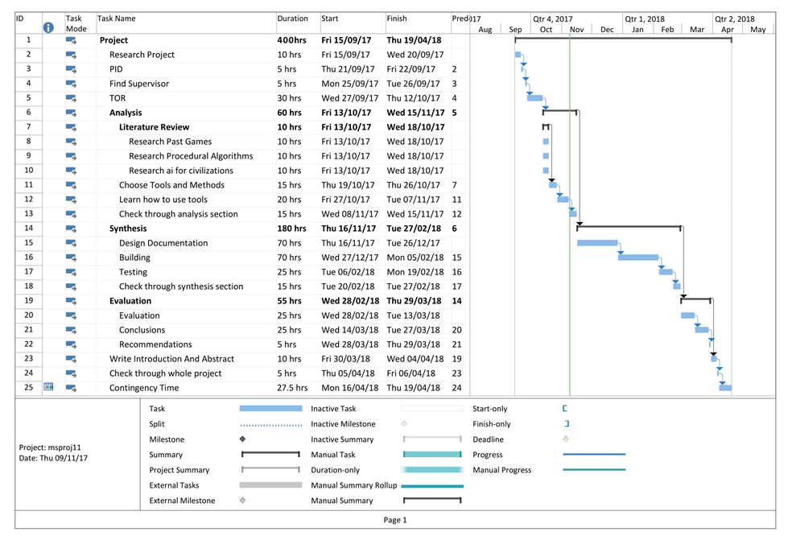



**Faculty of Engineering and Environment**

#### RESEARCH PROJECT: ETHICS REGISTRATION AND APPROVAL FORM

**Section One: Registration *[To be completed by researcher]***

|  |  |
| --- | --- |
| **Title of research project/dissertation** | **Civilization Simulation Game** |

|  |  |
| --- | --- |
| **Researcher’s name** | **Elliot Anderson** |

*Please only complete the following if researcher is a student:*

|  |  |
| --- | --- |
| **Programme of study** | **Games Programming** |

|  |  |
| --- | --- |
| **Academic Year** | **Year 3** |

|  |  |
| --- | --- |
| **Module code (if applicable)** | **CM064** |

|  |  |
| --- | --- |
| **Principal Supervisor or Module Tutor** | **Clifford Brown** |

|  |  |
| --- | --- |
| **Start Date** | **28/09/2017** |

**Brief outline of research topic:**

To create a sandbox game which simulates the development of civilizations as they adapt and react to the generated conditions around them.

**Short description of proposed research methods including identification of participants:**

Participants will be other people on my course. They will first play the game I will give out a questionnaire to receive feedback to identify errors and compare objectives. I will ask the questions on what can be improved and to see if they found the program easy to use without help. I will also ask them if they ran into any bugs.

|  |  |  |
| --- | --- | --- |
| **Ethical considerations in the research project** | **YES** | **NO** |
| 1. Does your research involve an external organisation or partner? |  |  |
| 2. Does your research involve human participants? |  |  |
| 3. If yes to Q.2, will you inform the participants about the research? |  |  |
| 4. Will you obtain their consent using the standard consent form? |  |  |
| 5. Is any deception involved? |  |  |
| 6. Do any participants constitute a ‘vulnerable group’?  (refer to definition of Vulnerable People) |  |  |
| 7. Will the research involve the following information?  Commercially sensitive  Personally sensitive  Politically sensitive  Legally sensitive |  |  |
| 8. Is the research likely to have any significant environmental impacts? |  |  |
| 9. Are there likely to be any risks for the participants in your research? |  |  |
| 10. Are there likely to be any risks for you in conducting the research? |  |  |
| 11. If yes [to 5, 6, 7, 8, 9 or 10 above] have you identified steps to address the issues and mitigate any risks to participants, yourself or the environment? |  |  |

**Statement to explain how any issues identified above will be addressed and what steps will be taken to mitigate such risks or adverse impacts**

•Information to be provided to all participants

•Participant consent to be obtained using the standard Research Participant Consent Form or otherwise in accordance with Faculty procedures

•Data to be stored and destroyed securely in accordance with University guidelines

•Adherence to Data Protection Act

•Anonymity to be offered to participants

•Commercial confidentiality to be provided to organisations

**Ethical category of research project**

Based on the above Ethical Considerations and with reference to the University’s Ethical Scrutiny Risk Assessment tool identify the Ethical category of your research project (refer to <http://www.northumbria.ac.uk/static/5007/respdf/riskassesmenttool> for further guidance):





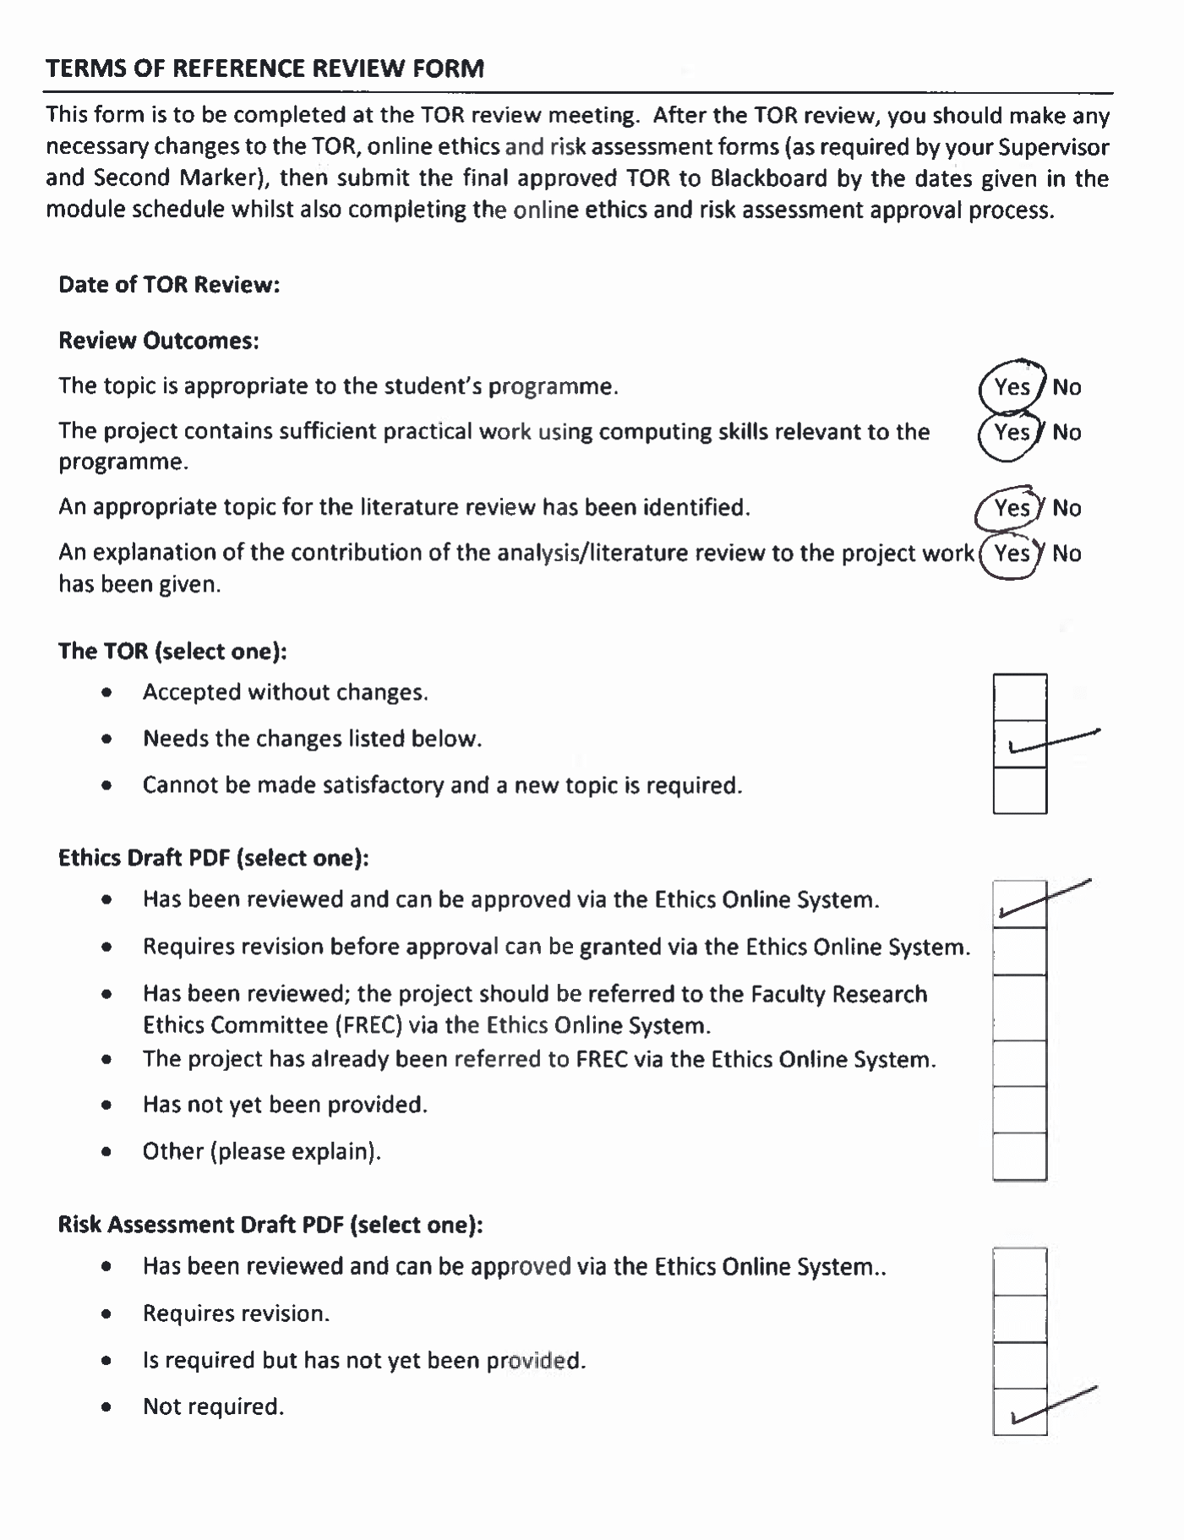

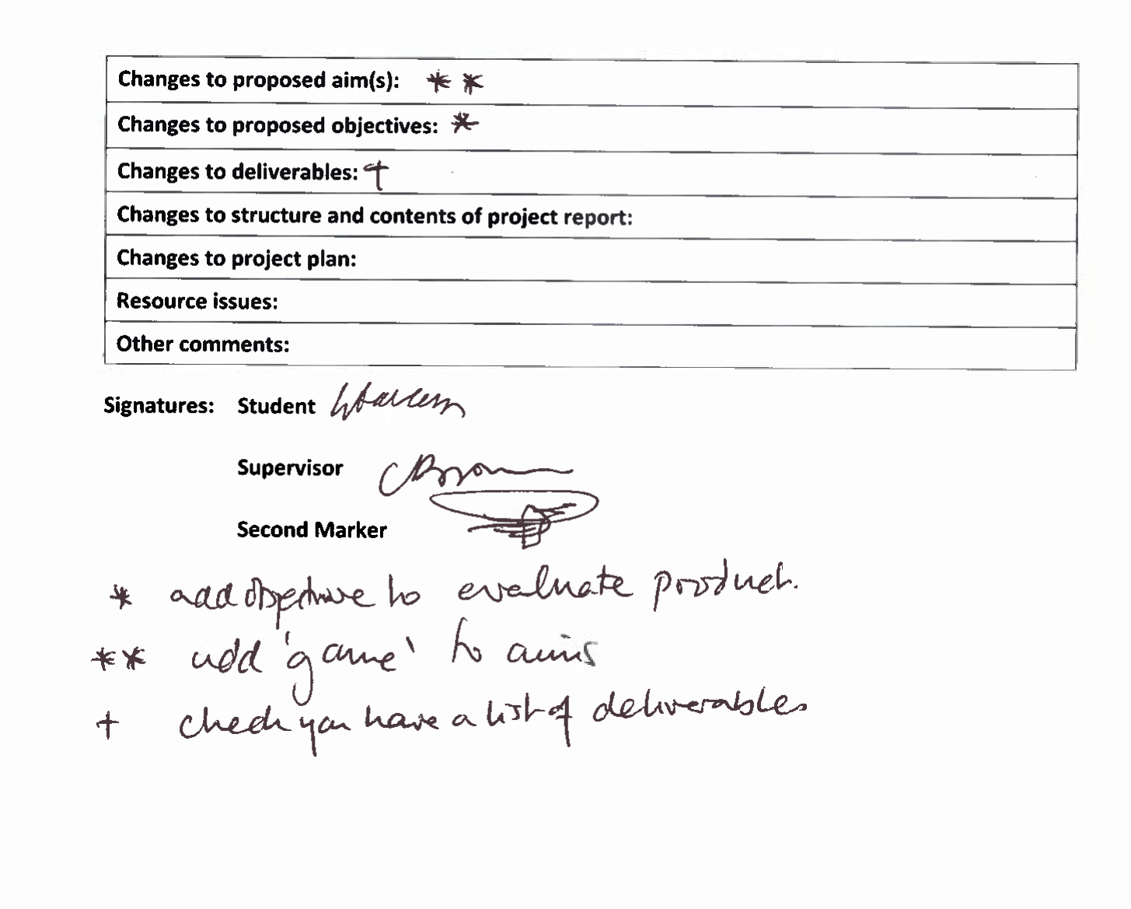

# Appendix B Jobs

### Jobs cut from the game

### Builders

Others have a much different routine such as jobs which make use of the resources rather than just gathering them. These consist of builders which build roads and buildings which expand the civilisations outwards.

Each building or road piece will need a certain amount of resources to build. This will all be chosen by the building manager.

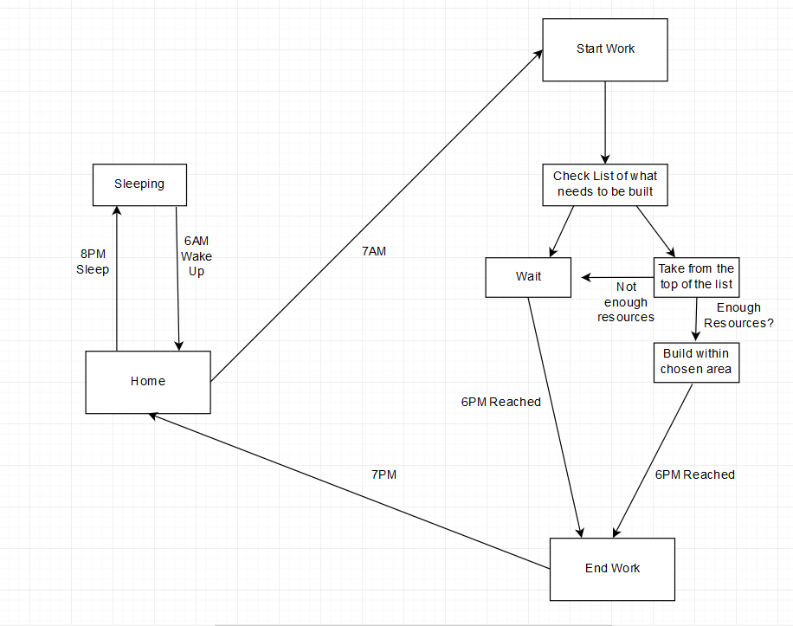

This is the daily routine of a builder. It shows that:

* A builder wakes up at 6AM
* Starts work at 7PM
* When work commences, it will retrieve the list of things that need to be built which is created by the building manager.
* It looks at the top of the list, which is sorted by priority.
* If there is not enough resources to build it, the builder waits.
* If there is enough the builder will build within the vicinity of the town.
* When 6PM is reached work will end.
* And finally, at 7PM they will head home and go to sleep.

### Building Manager

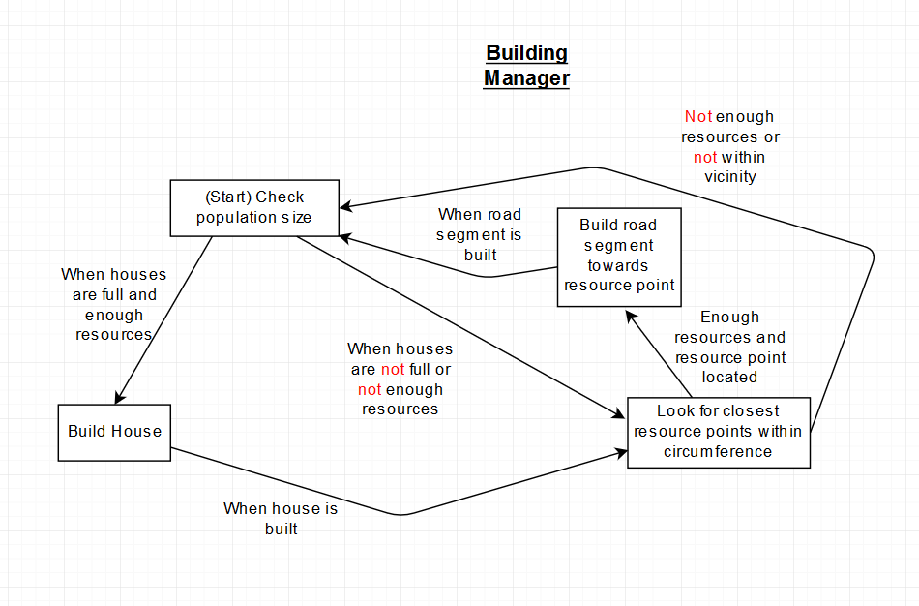A building manager is needed to figure out what must be built, their priorities and where things will be built. The sort of things the manager will consider when choosing what to build is the population and need for certain resources. Houses must be built to meet the demand of a population size while roads will need to be built for quick access to wood, stone or water.

This state machine for the building manager shows that:

* The manager will check the population size.
* When the population is large enough to fill the houses and there are enough resources to build them, new houses will be built.
* After this it looks for the closest resource points within circumference. It also goes straight to this point if the houses are not full or if there are not enough resources.
* If there are enough resources to build a road segment and a resource has been located, then build the road segment in the direction of the resource point.
* When the road segment is built repeat from the start.

#### Non-Cut

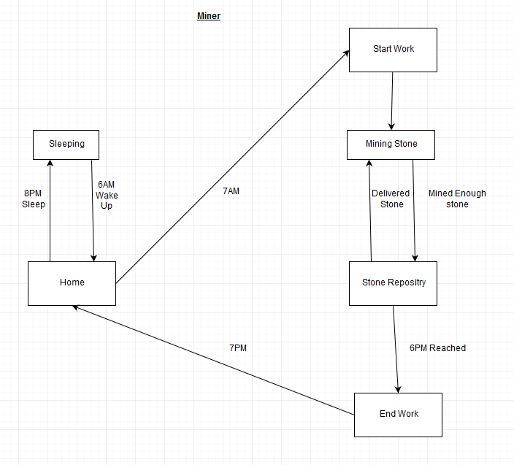

# Appendix C Testing

## External Testing

**Participant: 1**

**Was it clear what you were doing?**

Not really, there was a lack of instructions.

**What did you like about it?**

You can generate a world based on any word. Likes looking at the little people.

**What did you not like about it?**

Not much interactivity, just looking.

**What did you think of the UI? Improvements?**

It was ok. Once you knew what you were doing it was ok.

**What do you think of the controls? Any improvements?**

Need instructions, wants settings to change the speed of the navigation, didn’t know to use the keyboard to move around.

**What do you like and dislike about the AI?**

Seemed kind of like real life in the sense they were building, expanding, growing, living. Would be cool if you could drop things in and have them react to it.

**Is there anything you like/dislike about the design?**

To the point, fits purpose.

**Participant: 2**

**Was it clear what you were doing?**

No, no instructions giving for what you were doing. Wasn’t clear which entitles were interactable, could click on buildings and players but not animals.

**What did you like about it?**

Liked that you get a preview before going into the world. Likes the terrain was clear, cohesive aesthetic.

**What did you not like about it?**

No clear direction of what you were supposed to be doing. Would be nice have animals have animations.

**What did you think of the UI? Improvements?**

Scrolling while in the entity information box it zoomed out the map. Should Only zoom when hovering over terrain. Important buttons weren’t yet implemented. Should be a way to get back to the menu. Liked the bar across the top. Menu was clear what everything was supposed to do. Could make it clear to generate civilisation to apply the seed before clicking start simulation.

**What do you think of the controls? Any improvements?**

Initially tried to move around the map by clicking and dragging, which didn’t move. Should have something to tell you how to control. Maybe options to change control styles. Can go outside the map.

**What do you like and dislike about the AI?**

Disliked how massive sand bars were built across water, doesn’t like that feature.

**Is there anything you like/dislike about the design?**

Entity information boxes are boring. Bar across the top boring. Good have a nice-looking border not grey. Buttons in the main menu boring. Like the background menu, would be better if it was moving or changed.

**Bugs?**

Preview map is mirrored to the in-game terrain map. Target reticule is offset incorrectly on non-citizens. Strange black bar appears when zooming in far.

**Performance?**

It lags when speeding up especially in the mornings. Takes a while to start. Maybe make preview less detailed to speed it up.

**Participant: 3**

**Was it clear what you were doing?**

No, it wasn’t clear what was going on. It needs to have on screen instructions, some form of tutorial. Key binds on screen stuff like that.

**What did you like about it?**

Liked that you can change the timescale. Can look at each invidual and see an insight into their lives. Jobs married etc.

**What did you not like about it?**

Easy to lose track of villagers that you had previously clicked on to check up on later time.

**What did you think of the UI? Improvements?**

The menu was confusing. The console on the bottom right had variable font sizes which made it hard to read, some of the text was cut off. For the inspector and took you somewhere else it was confusing to know where you are in the menu. Scroll bar should return to the top. A back arrow to go back to previous selection. The main menu was simplistic, good clear preview of map. Like putting in seed and previewing it when you click generate. Liked the timer at the top. Would be good if you could move it around.

**What do you think of the controls? Any improvements?**

Keyboard controls are good although whenever you touch WASD it would move the ui when you don’t want it to. Make it so that the camera doesn’t move at the same time or remove functionality.

**What do you like and dislike about the AI?**

Dislike that the bridges were built in places which didn’t make sense, bridges start looking jagedy and out of place. Animals don’t show that they dead, they just top moving. Liked they returned to their houses at night. When they build roads in the city it is more square but building paths is not. He thought to make it more square when building back.

**Is there anything you like/dislike about the design?**

The vivid colours, art style, simplistic main menu which was too the point. Would be nice if there were animations. When going different directions show them facing that direction.

**Bugs?**

Camera can go past view bounds and go upside down. Dead people don’t get removed. Citizens glitch through walls when there is a lot of lag.

**Performance?**

Lots of lag, lag increases over time.

## Internal Testing

|  |  |  |  |
| --- | --- | --- | --- |
| Test Number | Function | Expected Outcomes | Status |
|  | Typing a seed and pressing generate | New generated map appears in the box and will appear during the simulation when it is started. | Pass |
|  | Typing the same seed multiple times | Same map appears with the same seed | Pass |
|  | Changing the number of civilizations on the menu | When simulation starts there should be that many spawning. | Pass |
|  | Clicking on a citizen, civilization or settlement | Camera zooms and moves to the selected object. Stats or actions related to the object should appear in the box | pass |
|  | Citizens health has reached 0 | Citizen dies and text box reports this, | pass |
|  | Citizen’s age is over 100 | Randomly they should die of old age | pass |
|  | Citizen can’t get over a body of water. | Builds a bridge so long as there isn’t one within a certain radius | pass |
|  | Citizen can’t get over a body of water and there is one within a certain radius | Goes to the nearest bridge and crosses to the other side | Pass |
|  | Civilization automatic Assignment of jobs | Jobs should be almost equally spread out | Pass |

# Appendix D Requirements Table

|  |  |  |  |  |
| --- | --- | --- | --- | --- |
| No. | Design Category | Priority rating | Requirement | Justification |
|  | Pause Menu | Must | While in-game: Pressing the ESC key brings up the pause menu. | Provides a way for the player to get back to the main menu or quit. |
|  | Pause Menu | Must | Pressing the ESC key again or pressing resume will close the menu. | Provides a way for the player to close the menu once it has been opened. |
|  | All Menus | Must | The mouse will be used to select the options on the menu. With the left mouse button allowing you to select them. | It is important to be able to navigate through the menu, the mouse allows this. |
|  | Pause Menu | Must | The options to select on the menu will be resume, return to main menu and quit. | Three easy options to select, which are options needed for the player to easily access. |
|  | All Menus | Low | A sound will play and colour goes dark when clicking on buttons. | Provides feedback to the player that the button has be successfully clicked. |
|  | All Menus | Should | Buttons indicate they’ve been highlighted by going a darker colour. | Provides feedback to the player that their mouse is above the button. |
|  | Start Menu | Must | When the game starts, a menu is shown showing the title and four options; Generate New World, Options, About and Quit. | The title tells the player what game they are playing, and the options provide the player with the choices needed to start, quit change settings or learn about the game and it’s controls. |
|  | Generate New World Menu | Must | When loaded, the menu shows a preview of the generated map, a seed input area, a go back button and start simulation button. | This allows the player to see what the map will look like and allows them to pick a different one by typing a new seed. |
|  | Generate New World Menu | Must | When typing into the seed input box you need to press generate to see the new map. | This allows the user to know that this will be the map generated from the seed. |
|  | Options Menu | Should | The options menu shows a slider for music and sound effects clearly labelled and a go back button. | Allows you to be able to change the volume of music and sound effects and a button which enables you to return to the previous menu. |
|  | About Menu | Must | The about menu shows controls and information about the project. This includes credits and an explanation of what the simulation is. | This information needs to be communicated to the player so having it in the menu is a good place to have it where it is all clearly laid out. |
|  | In-Game GUI | Must | The current in-game date and time is displayed at the top. | This is important information for the game to show the length of time that has passed |
|  | In-Game GUI | Should | A mini-map showing the whole island no matter what zoom level. | Allows the player to easily see the whole area of the map. Can be useful in figuring out where you are relative to the whole map. |
|  | In-Game GUI | Should | A black square on the mini-map which shows where the camera is relative to the world. | This allows the player to see exactly where they are looking on the map. |
|  | In-Game GUI | Should | An action button which, when pressed gives options on what actions can be done such as erupting a volcano, placing terrain, etc | The player needs an easy way to access their abilities and so the button will provide this. |
|  | In-Game GUI | Must | A stats button which has a list of current villages and cities along with their inhabitants. | Adds to the players insight over the sandbox. Gives details to the player of all the stats that they may want to see. |
|  | In-Game GUI | Must | Clicking on citizens, cities and houses will focus the camera on them and put a square around them to show they have been selected. The stats menu will show the details about them.  The actions menu will also change to reflect what can be done to the focused on entity. | Gives insight into the individual entities of the simulation. Also allows you to keep track where they are since a square shows they have been highlighted. |
|  | In-Game GUI | Must | Details in the stats menu per citizen will list things like parents, house they belong to etc.  These are shown as buttons which can be clicked on in this menu. Clicking will focus the selector on the entry linked to the button. | Good way of finding more about citizens and selecting other entities. |
|  | In-Game GUI | Should | UI box’s have a cross in the corner which allow the user to get rid of them until they decide to open them up again. | Frees up space on the screen. |
|  | In-Game GUI | Must | Zoom in and zoom out buttons which allows you to get a closer or further away view. Using the mouse wheel does the same thing. | Adds to the players control over the sandbox. This allows the player to get a closer look at the world or a better overall view. It is important for the player to zoom in as it gives them a better look at what they want to see, or what they want to click on. |
|  | In-Game GUI | Must | Pause time toggle button, which allows you to start and stop time. | Adds to the players control over the sandbox. It can give the player time to think and analyse things at a certain moment. |
|  | In-Game GUI | Should | A fast-forward button along with a multiplier showing how many times faster the time is currently at. | Gives further control to the player, the player might want the civilisations to build faster for example.  Also, nothing much may be happening so fast forwarding can allow it to go past that. |
|  | In-Game GUI | Must | A text box which tells the player of events that have occurred such as marriage, births and deaths. | It is a good way to inform the player of important events in the simulation. It gives a greater understanding of what is going on. |
|  | In-Game GUI | Could | When starting the game there will be an option to set the survival level . This is how hard it is for civilisation to thrive. Setting it harder will make gathering food worth less for example. | Allows you to see the difference between a thriving and non thriving civilisation. |
|  | In-Game GUI | Should | There will be an option when starting the game to choose how many civilisations will be spawned. | Gives the user more control over the simulation. |
|  | World | Should | The world is randomly generated with textured tiles depending on the terrain. | Having the world randomly generated with tiles allows for it to be easily manipulated with tiles being switched with ease. |
|  | World | Must | The world has multiple terrain types; Beach, mountain, rocky, woodland, water, snow. | The terrain types are needed to give structure to the world which the citizens will use to survive. For example, trees grow in woodland so these tiles can be taken. On the other hand citizens can not cross mountain, so each type gives them different behaviours. |
|  | World | Must | The map can change based on citizen action, such as building roads, or cutting down trees. | This is needed to show the citizens effects on the land. It needs to change for the player to see. |
|  | World | Must | The map can change based on player action. | This is so that the player can see their own effects on the land. Such as a tornado could wipe out some woodland and so the player would see the dark green woodland tiles replaced with grass. |
|  | World | Could | Disasters can occur | Disasters can naturally occur in the world to give variance to the sandbox and give interesting results. It will also show its effects on the civilisations and how they adapt to them. |
|  | World | Must | Plants and animals are spawned on the map on their appropriate terrain | They are spawned for hunter-gatherer citizens to hunt and gather for food. |
|  | World | Must | Animals roam around randomly. | Animals would move around in real life and gives challenge to hunting |
|  | World | should | When it is night time there is a dark blue coloured overlay across the screen. When it is morning it is light. | Shows that it is night time |
|  | A.I. | Must | Citizens will avoid going in water or high mountains. | Citizens don’t want to drown, makes sure they live and behave like people. |
|  | A.I. | Should | Jobs will be spread out across citizens almost equally. | Makes sure jobs are not unbalanced |
|  | A.I. | Must | When a citizen does not have enough food they will lose health every hour until they die. | Simulates starvation. |
|  | A.I. | Must | Villages start as tribes | Civilisations usually start as simple tribes in real life, so it would make sense for them to do so in the sandbox. |
|  | A.I. | Must | Children are born only to dwellings with adequate food supplies | To create sustainable growth for the civilisations it makes sense for children to only be born when there is enough food or else they would die before entering adulthood therefore the civilisation would never grow. |
|  | A.I. | Must | When a tribe has reached a certain population, it becomes a town. (Level 2) | As with civilisations in the real world, when a settlements population increases, it will grow. This happens with tribes as they become a town, it represents growth. |
|  | A.I | Must | When a village has reached a certain population, it becomes a city. (Level 3) | The same way as the previous it shows the civilisation is getting bigger. |
|  | A.I | Must | Upgrading houses from tents, and then from houses to big houses requires a certain amount of stone. Normal houses require you have are a village, while big houses require you are a city. | This makes the game more realistic. |
|  | A.I | Must | Individual citizens have daily routines based on their assigned job. | This feature better represents a realistic system. |
|  | A.I | Must | Scouts look around until they find a resource source, where they will then build paths back to the civilisation | This feature better represents a realistic system. |
|  | A.I. | Must | Path layers build paths to each house | Like the real world helps citizens travel faster to houses. |
|  | A.I. | Must | Woodcutters will head to the nearest wood to chop trees. | It’s a way to get wood. |
|  | A.I. | Must | Miners will head to the nearest mines to mine stone. | It’s a way to get stone. |
|  | A.I. | Must | Hunters and gathers gather edible plants and kill animals for food. Each hunter or gatherer will go towards a different target.  When they have retrieved what they want from the target they take it back to the civilisation which will increase food. | It is how they transfer what they got like real life. |
|  | A.I. | Must | Farmers- Grow and farm animals for food. Having farmers produces a certain amount of food each day. Farms can only be built on civilisation level 2 or above. | Makes large populations sustainable like real life. |
|  | A.I. | could | There are miscellaneous jobs which don’t have an unusual daily routine which usually just consists of going to a building then going home. These would be jobs like teacher. | This is just for fun, it is also realistic. |
|  | A.I. | Should | Paths and roads speed up citizens when they walk across them. | Gives citizens a way to get to destinations faster. |
|  | A.I. | Must | If a citizen is stuck behind a body of water they will build a bridge towards their destination. | Enables a way to get to a certain location if water is too hard to traverse around. |
|  | A.I. | Must | If a citizen is stuck behind a body of water and there is another bridge within a certain radius, instead of building a bridge they head to this bridge. | Stops citizens from building too many bridges. |
|  | A.I. | Must | Citizens will get married randomly each day. When married one of the engaged will leave their old house and join their spouse. The wife will gain their husbands second name. | Tries to make marriage as realistic as possible. Married couples don’t usual live in different houses. |
|  | A.I. | Must | Married couples can have children which happen randomly. When born a child will live in the house until they are over 18. Children cannot get married or have jobs. | A way of making having children sustainable. Historically most children are born to married couples. |
|  | A.I. | Must | Children inherit the second name from parents. | This happens in the real world. |
|  | A.I. | Should | A new citizen will immigrate to a city each day no matter how much food is available unlike births. | A way of mixing the gene pool, gets more people with different second names. |
|  | Sound | Should | Music will play on the main menu. | Give ambience and more engaging. |
|  | Sound | Should | Fitting music will play at day time along with birds in-game . | Gives ambience to day, signifies it is day. |
|  | Sound | Should | When night time comes the day music will stop and will start playing sounds associated with night | Gives ambience to night, signifies it is night. |
|  | Sound | Could | The closer you zoom to civilisations you will be hear crowd noises. | Makes it seem like civilisations are living. |

# Appendix F Passage Of Time

When it comes to the passing of time, it needs to be decided how time will pass relative to real life. For example, time cannot be realistic as time would pass too slowly to watch the civilisations develop. This would not be usable as a simulation so a work around needs to be planned.

A possible way of avoiding the issue of things happening too slowly is simply increasing the speed of time. Instead of it taking one hour for an hour to pass it would take one minute. This could work though this may still pass time way to slowly.

For example, the age of the citizens would need to be 1:1 with how many years pass.

To work out how long it will take for a year to pass, it can be worked out using this equation with x being how many minutes are in a day:

x*24*30*12

If we assume it takes 1 minute per hour, one year would take 8640 minutes. Which is equivalent 144 hours which is incredibly slow. The speed of time must allow sufficient space for towns to make significant growth within one sitting. The average time it would be expected that people would play with the program is probably something within the time frame of 30 minutes.

Next, I will see if lowering the time, it takes for a day to pass is a sufficient way to lower the length of a year while maintaining playability. Let’s say it takes 10 seconds per hour. The equivalent of 0.16 minutes. This should take 3.84 minutes to complete a day and 1382.4 minutes (23.04 hours.) While this is much faster, 23 hours to complete a year is just way too long. The next step would be to try even shorter days, but this is no good. As going any further will make the days too short to observe anything of significance. That is another point the citizens daily activities must be observed or they will be shown moving around in a blur.

We have ruled out that simply speeding up time does not fix the problem. Instead a fix maybe to change the increments in which age and time is increased. For example in the real world a day is 24 hours, we could change it so that every 24 hours there is a 10 day increase. This would effectively change the equation to:

x*24*3*12

This is because it will take the equivalent of 3 days to reach 30 days. With this new equation, and with 10 seconds per hour the time it takes for a year to pass will be: 2.3 hours. We are getting closer however it is still too much.

Six seconds per hour is probably the quickest we can make the base time without it being too fast so we’ll use that. This makes one year equal to 1.4 hours. Still not enough, but we can’t decrease the speed of a day any further. Instead we can alter how many months are in a year. This is ok because we are abstracting time, it does not need to be 100% representative of real life so long as the passing of time is represented. Let’s bring the number of months in a year down to 4 and instead of calling them months we’ll call them seasons.

This is what the equation looks like now:

x*24*3*4

With this new equation it will take 28.8 minutes for a year to pass. This means that within an average single sitting only one year will pass. To bypass this issue, we can alter the way in which citizens age. In the real-world people’s ages are counted in years. What if we change it so that citizens ages are measured in days. So, in an average session, a citizen will be 90 days old by the time they are done. The equivalent of 90 years. Instead of being only 1 year older they have a possibility of growing old and dying within a single session. This is important as it also allows children who are born to grow up and work multiple times. It is fine to do it this way as stated before the in-game time is completely abstracted to the time in real life.

In conclusion it is decided that each hour takes six seconds and after each day the day counter is increased by thirty. When the day counter reaches thirty a season increases by one and there are four seasons in a year. Finally, citizen age is measured in days rather than years.

# Appendix G Programming the Terrain Generation

**Terrain Generation Game Objects (empty objects not abstract)**

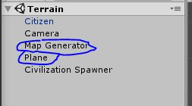In Unity, games are made up of game objects. These can either exist physically in the world, be empty or static. Abstract objects don’t necessarily exist visually in the game world, while the opposite is true for non-abstract.

The map generator is an example of an abstract object since it is a collection of code rather than a visual thing in the game. The map generator does have an output which is non-abstract. This is the map.

So, the first thing that was needed to start programming the generator was to create a game object to hold the code. This was an object called map generator. It is an empty game object right now.

Another object that is needed is a plane where the map texture will be generated to. This is simply a large square mesh.

**Generating the noise**

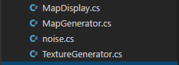At this point terrain generation will be done through four C# files. “MapDisplay.cs” will deal with rendering the texture to the designated plane, “MapGenerator.cs” will take care of most the terrain generation, “noise.cs” will deal with the noise maps and finally “TextureGenerator.cs” will turn the noise map into the right terrain colours.

In “MapGenerator.cs” the first thing that happens is it fetches a 2D noise map from the noise class so let’s look how that was achieved first.

In “noise.cs” a random number generator is passed a seed. This seed will be changeable in the unity inspector and is what makes the different generated maps look different. After this all the random numbers are passed into what is called an “Octave.”

The octaves are like multiple noise functions with varying frequencies and amplitudes, which are then added together. Each subsequent octave becomes less influential on the final result. This is to give the map more little details.

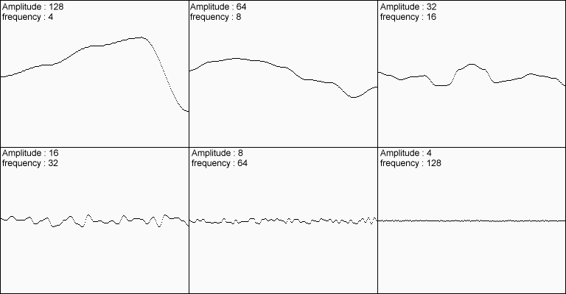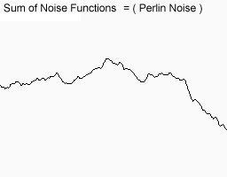

So there is a for loop which goes through a specified amount of octaves which is chosen in the unity inspector. The octave itself is simply an array of 2D Vectors, and they also have an offset added to each of them. The offset allows you to move the generation along the x or y-axis if needed; this can also be changed in the unity inspector.

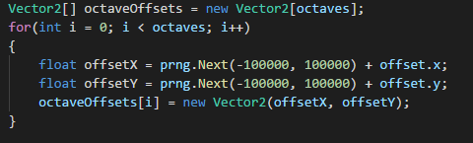

Then the noise map needs to be created using these octaves. To do this, another for-loop is used which goes through all the numbers within a specified map height and map width. Both of these values are changeable in the inspector.

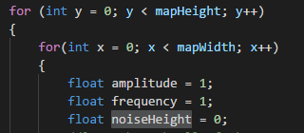So to make sure each octave is different some values need to be set before entering another for-loop for the octaves. These are the base values.

In the octave for loop, to calculate a specific height, a sample must be taken. To work out where this will be a calculation must be done. This is: “(x - halfWidth) / scale * frequency + octaveOffsets[i].x” and the same calculation would be done for the y-axis.

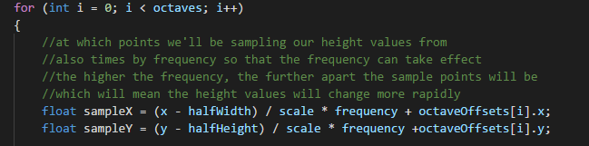To explain some points about the calculation, the halfwidth makes the middle point of the map the middle rather than the corner. The scale generates it with more detailed zoomed in or less detailed but zoomed out depending on what the value is set to. The frequency influences how far apart the sample points are so the higher the value the more it changes rapidly.

Next, a Perlin noise value needs to be generated using these numbers. This is how it is done in code:

It is simple since the Mathf library includes a Perlin function to make all the hard calculations for you. It simply needs to be passed the sampled height values from before. It is multiplied by 2 and subtracted by 1 so that it is always in a range from -1 to 1 as this is the range needed for the terrain to generate correctly.

At the end of the octave, the for-loop amplitude is multiplied by persistence and frequency is multiplied by lacunarity.

Amplitude is multiplied by persistence, which needs to decrease each pass of an octave. The amplitudes makes each subsequent octave weaker. Having a higher persistence gives other octaves more weight and thus will look a little more abstract. A weaker persistence will have stronger shapes but will look very little like an actual map. A persistence somewhere in the middle is best.

As explained earlier the frequency influences how far apart the sample points are, so the higher the value, the more it will change. Therefore a higher lacunarity would spread the map out further while a lower lacunarity would clump all the land together.

Since all of this is within a for loop going through every number in the noise map vector, it will keep repeating until everything has been calculated. The noise map can now be returned to the map generator.

# Appendix H Flow Implementation

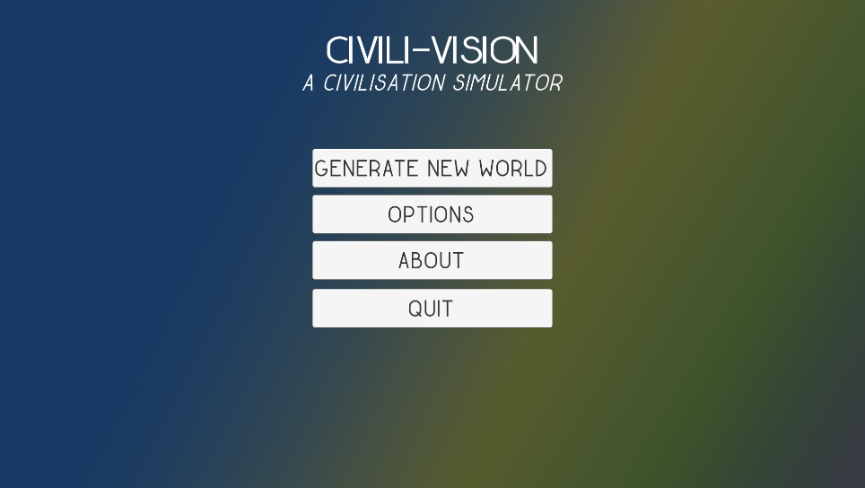

Figure The first thing the user sees is the main menu

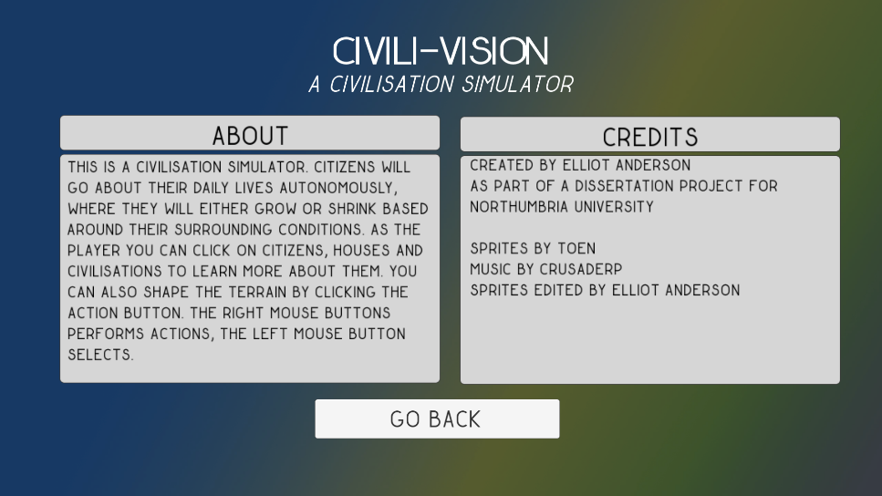

Figure The about page shows information on playing the game and credits

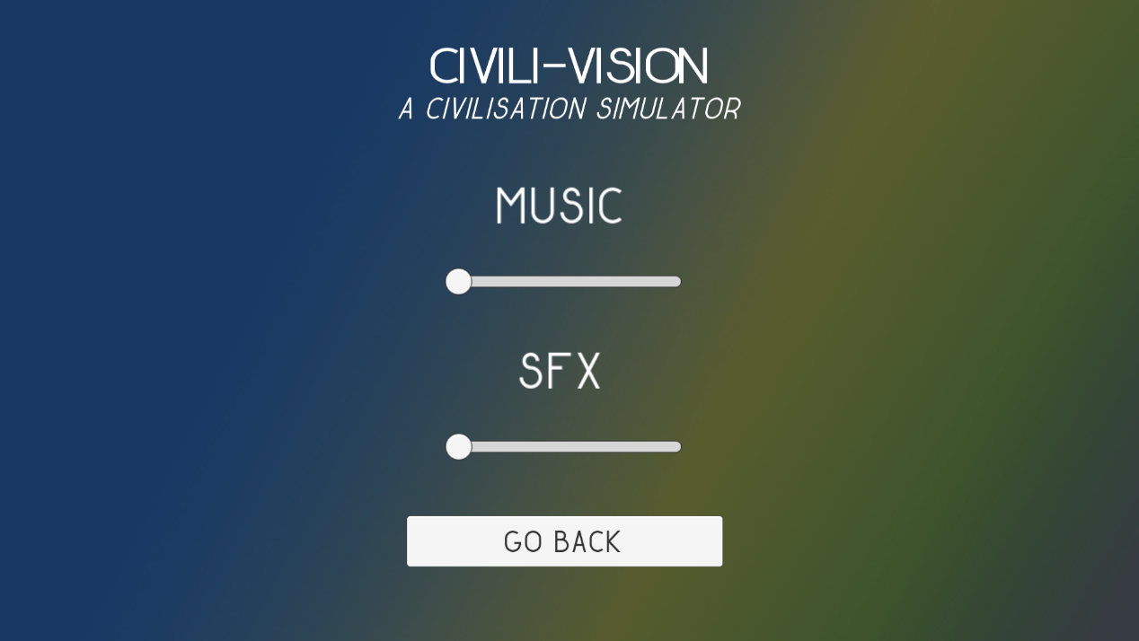

Figure The settings menu allows you to change sound volumes

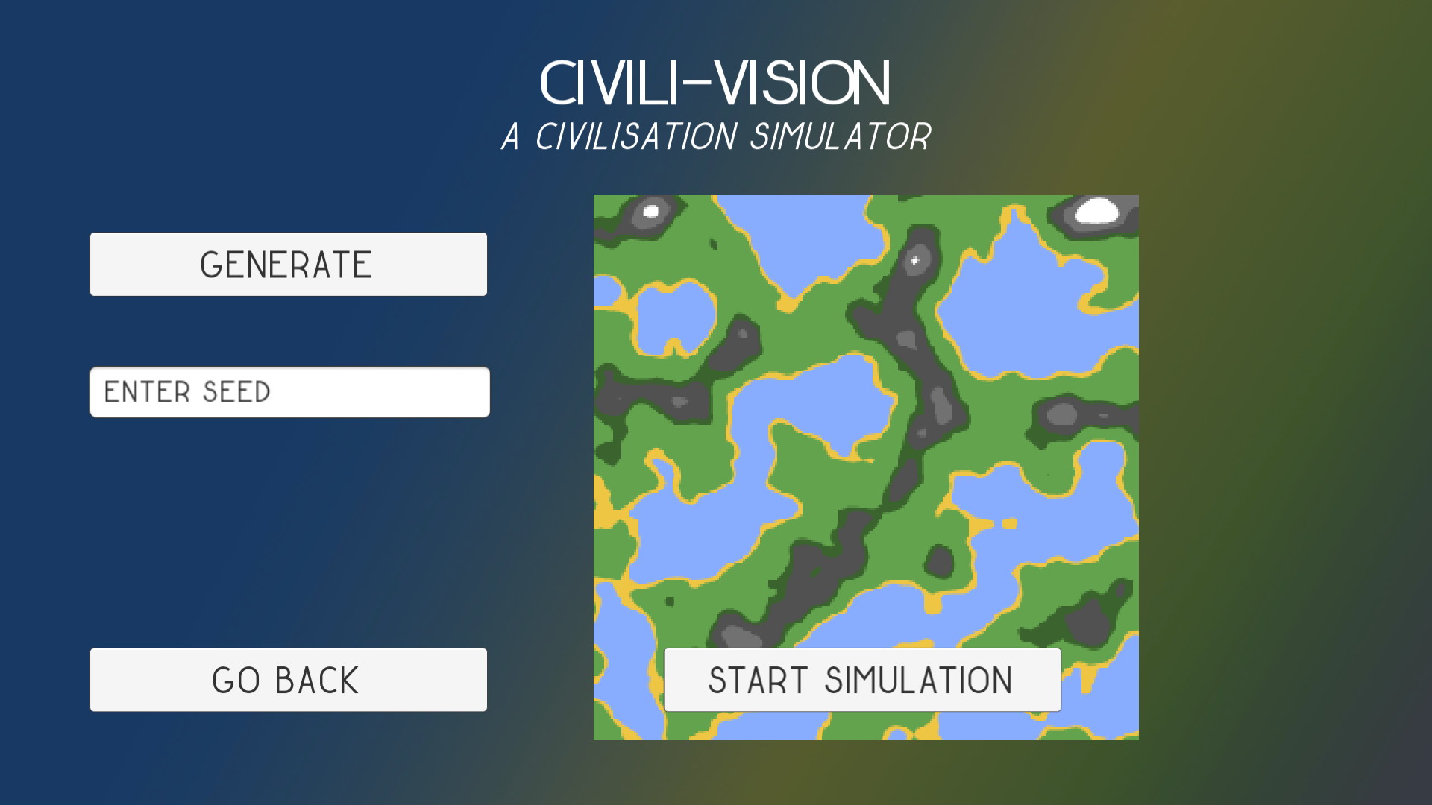

Figure This is the map generation menu

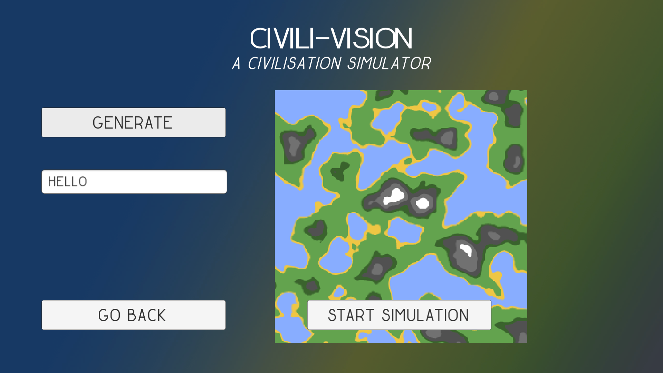

Figure As you can see, typing hello into the seed box will generate a map

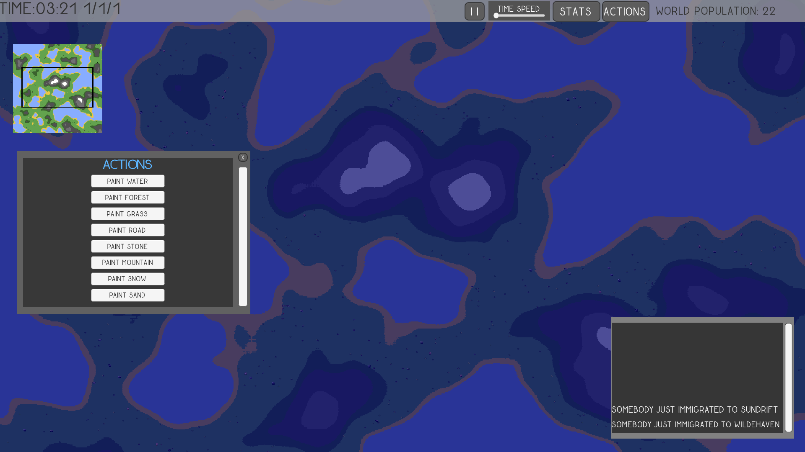

Figure This is the first screen the user will see upon starting the simulation. It is night time.

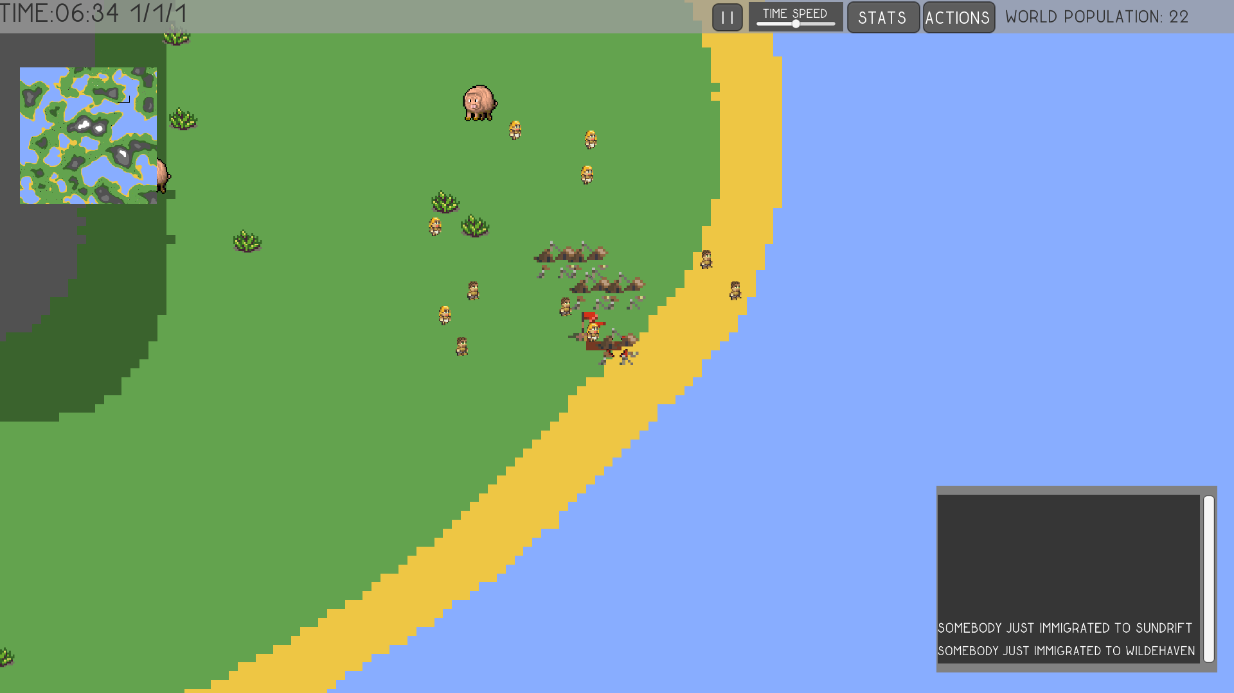

Figure This is a tribe, you can tell because it is clumped together and uses tents

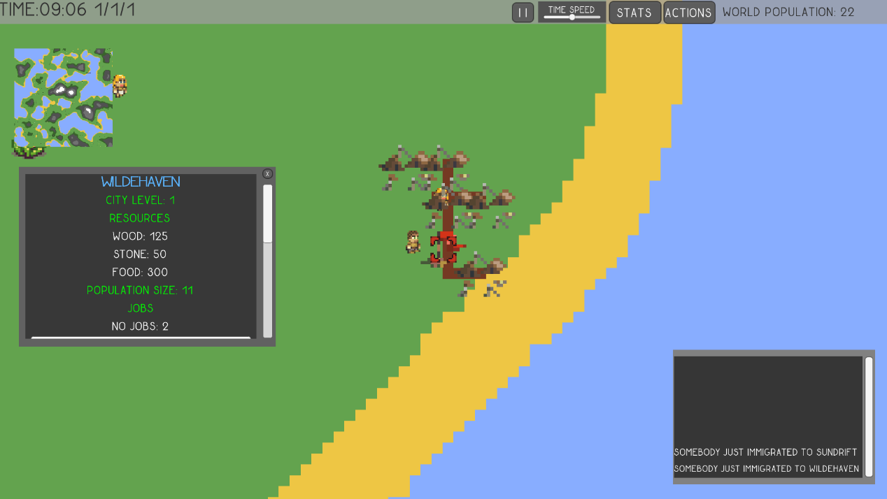

Figure Pressing the stats button brings up stats for the civisation

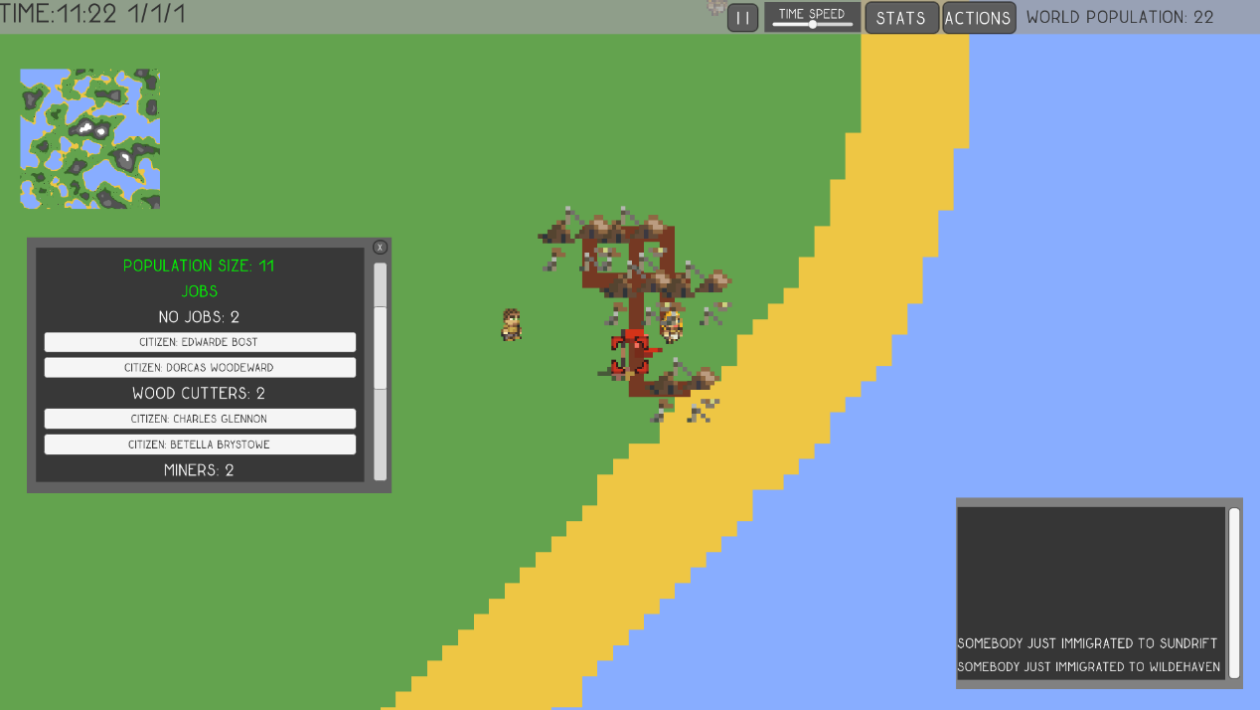

Figure You can scroll down and see everyone who has jobs

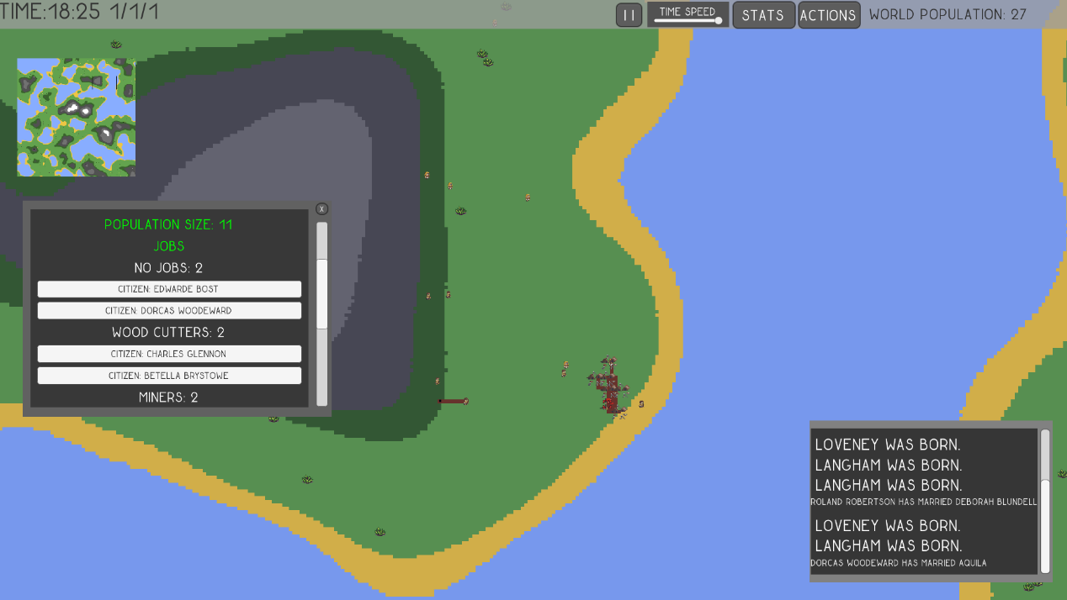

Figure As you can see this tribe has found a forest and have started building a road

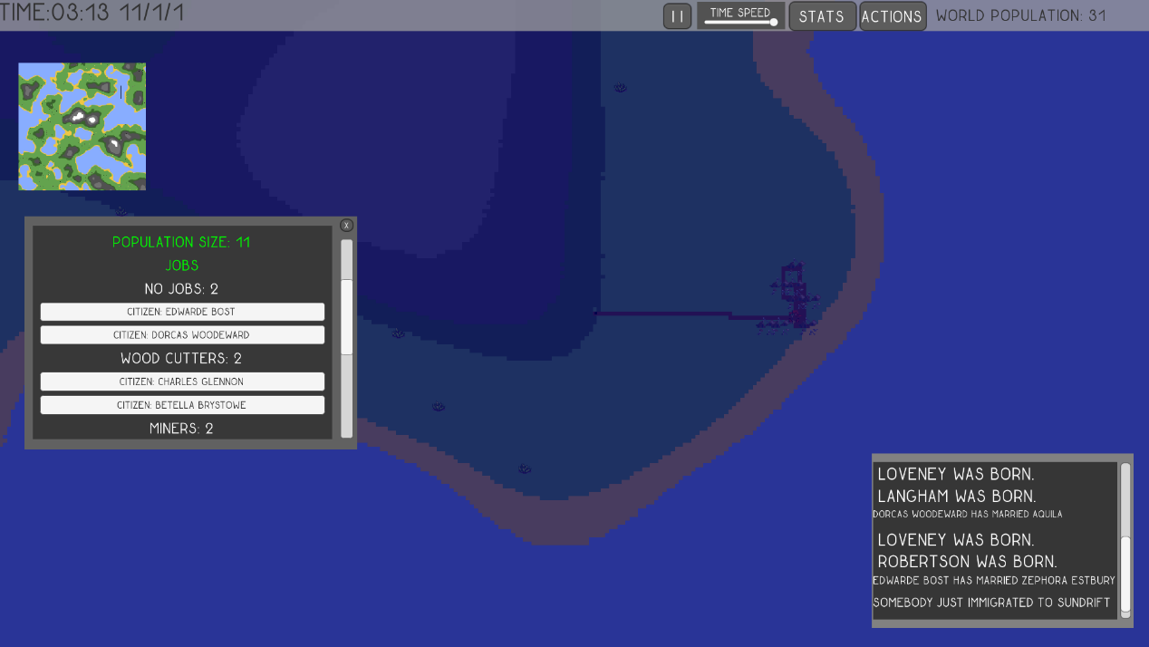

Figure The road has been built

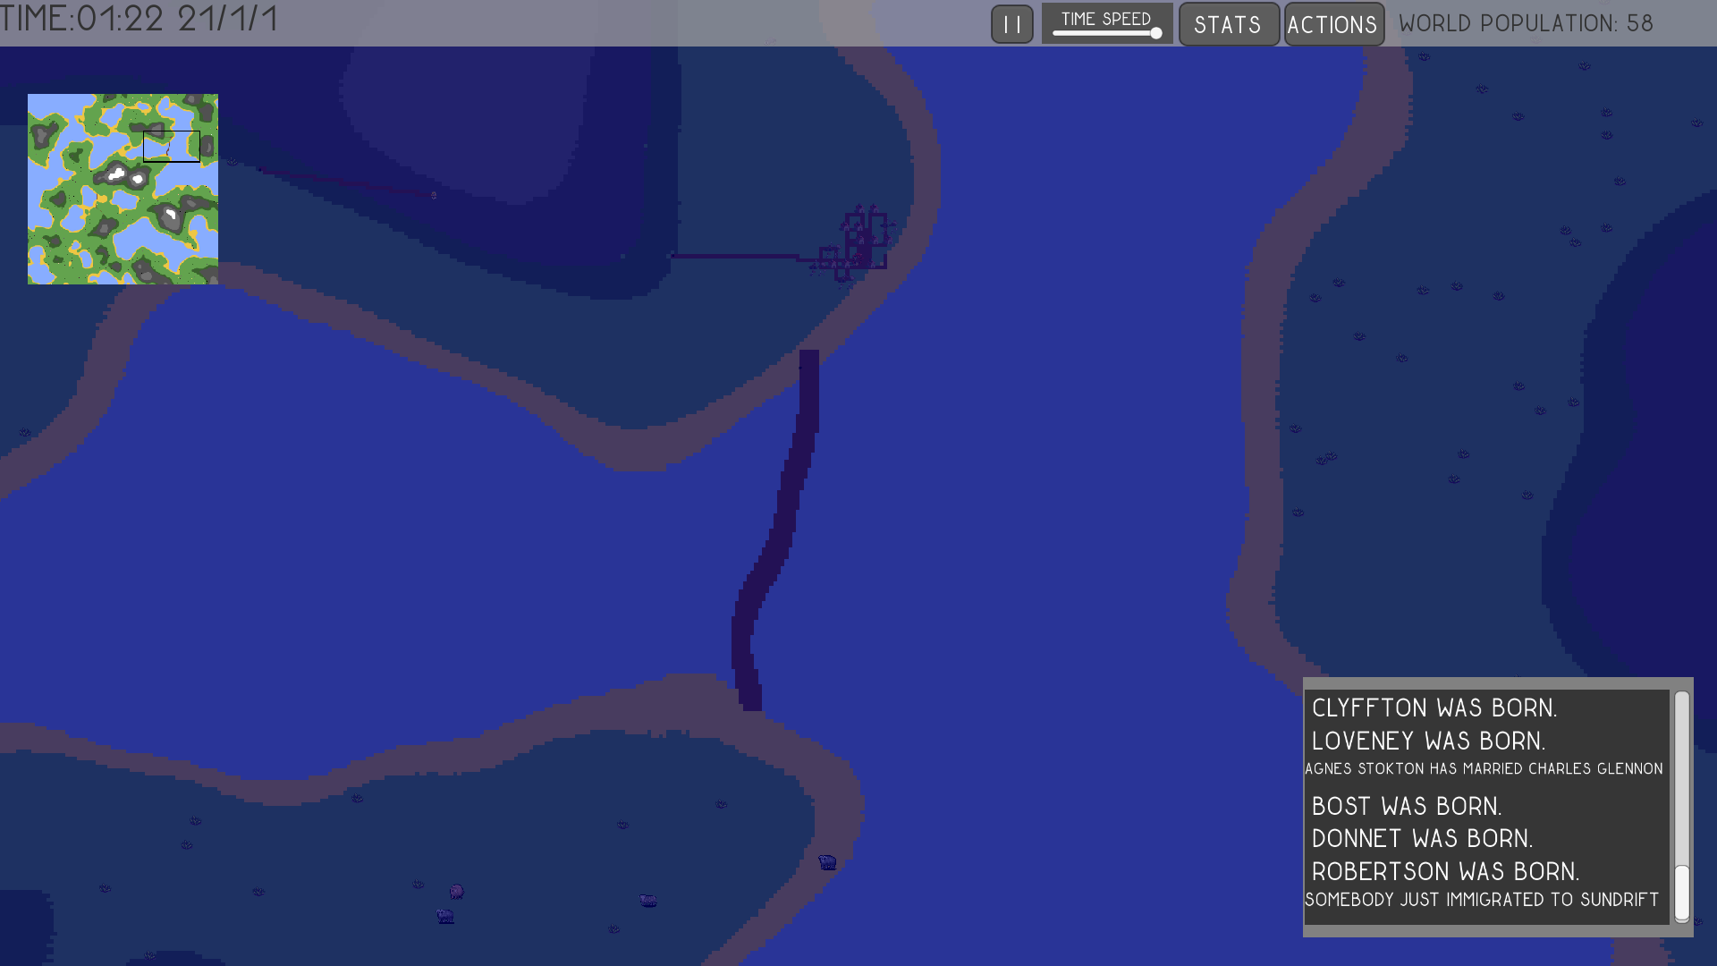

Figure A civilisation has built a bridge across the sea

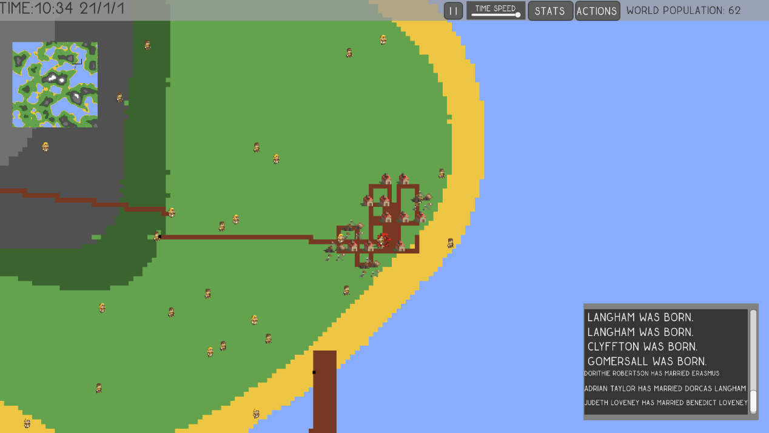

Figure This civilisation has became a town as they have started upgrading their tents to houses

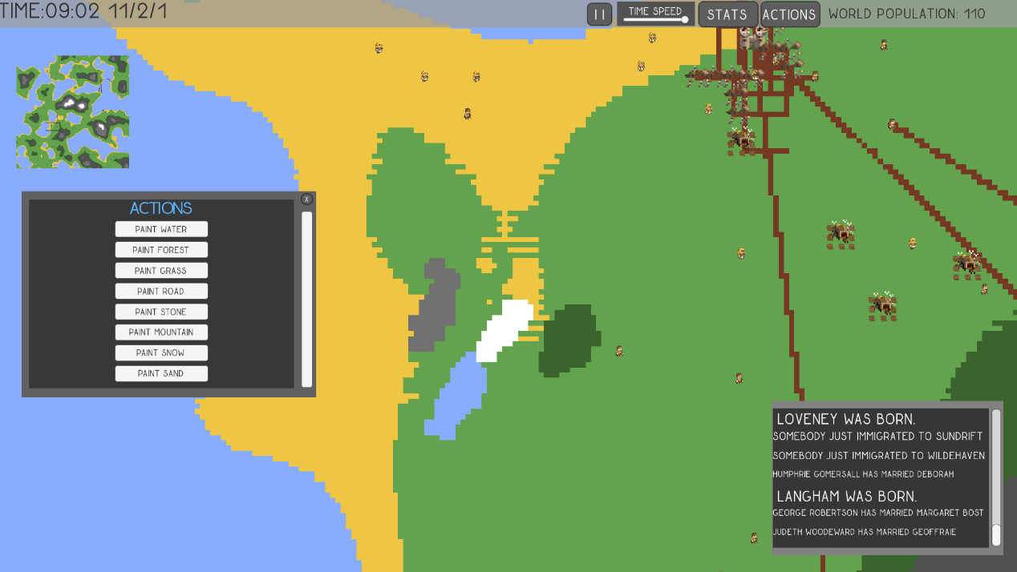

Figure This shows the actions menu, you can paint terrain.

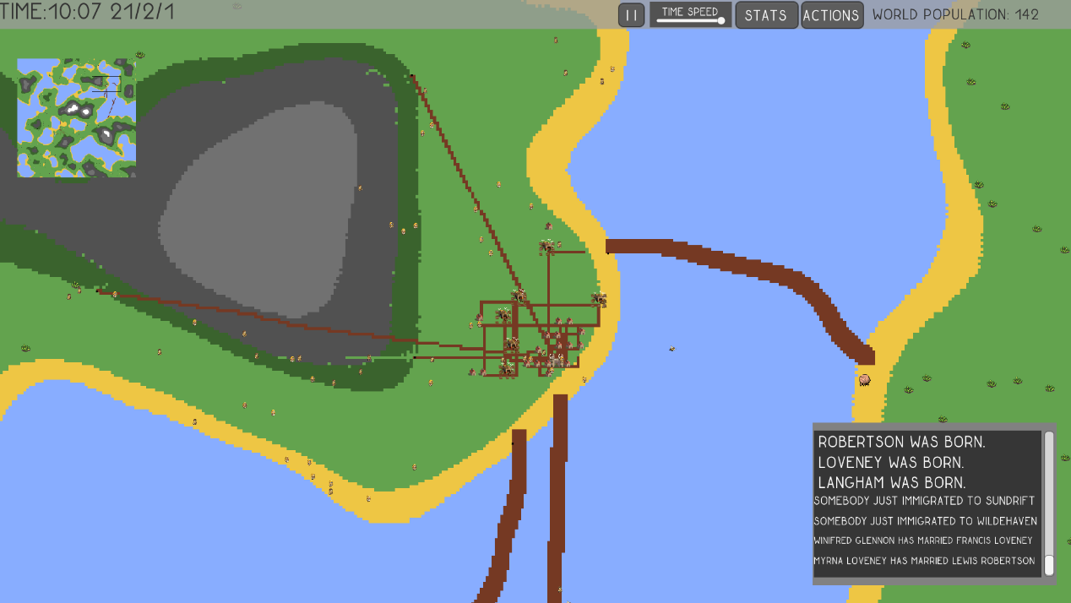

Figure This town is getting better and is sprawling out thanks to building farms.

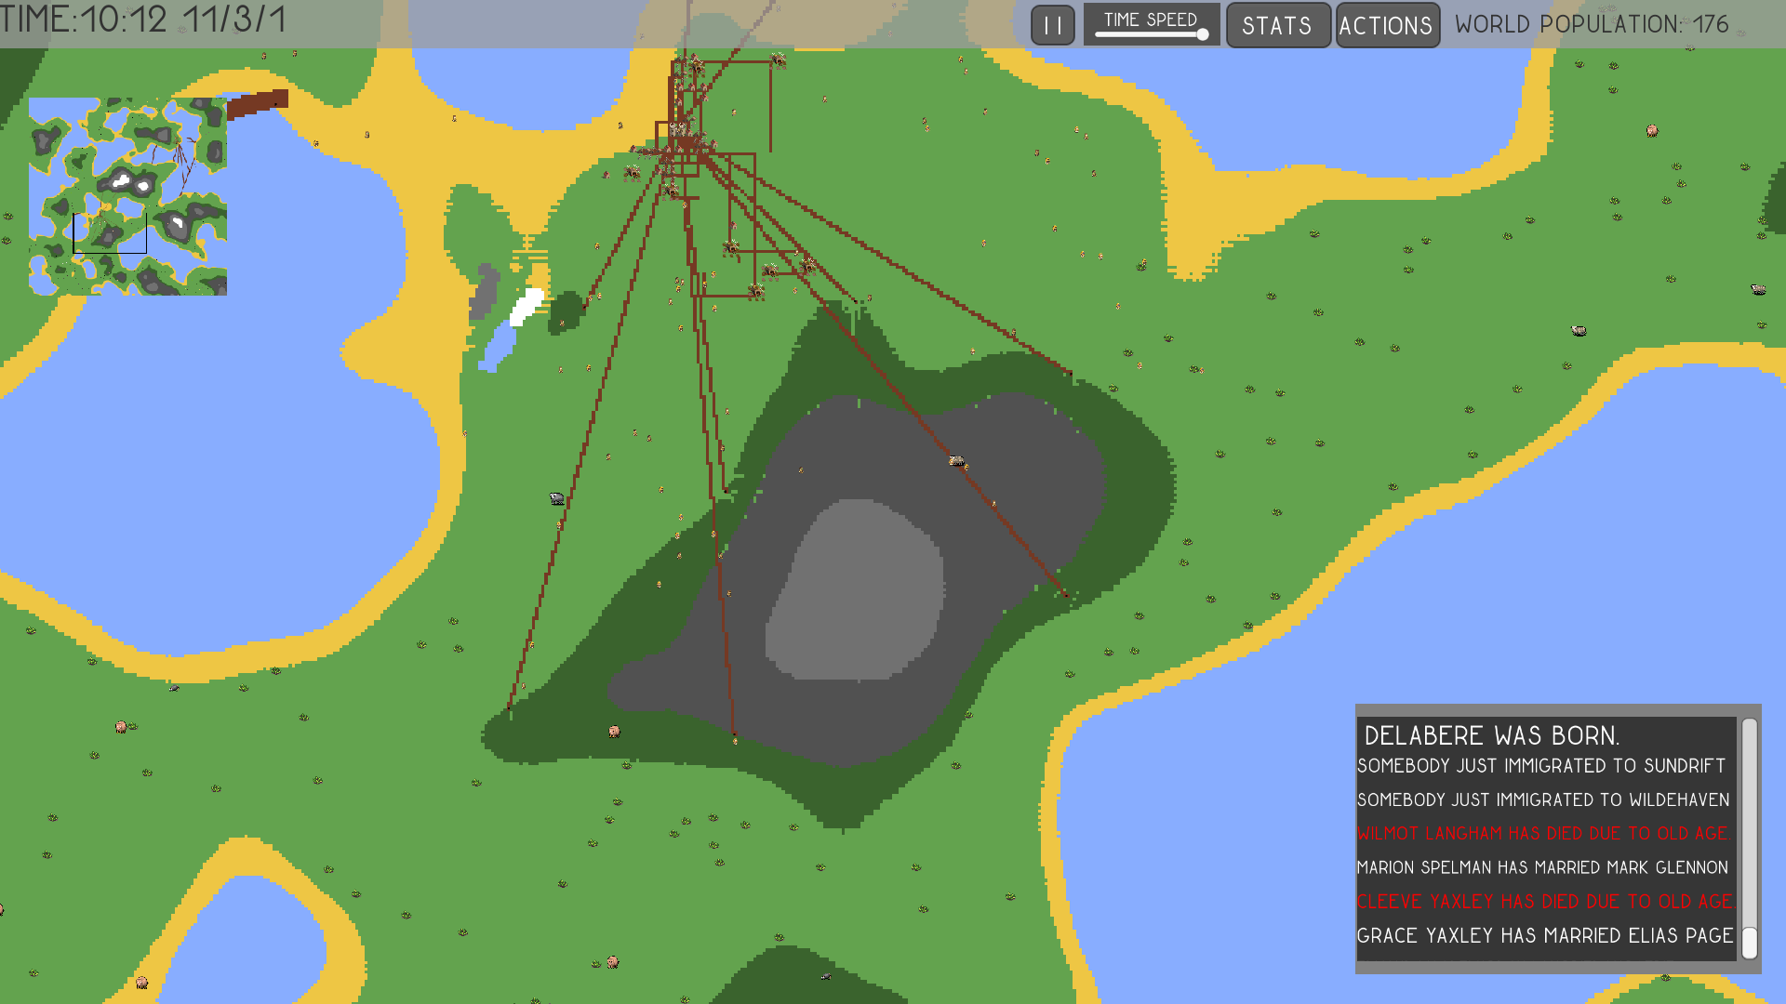

Figure You can see the civilisation affecting the environment, building roads. You can also see the forest and rock being taken away. You can see the gaps. You can see citizens are dying too in the bottom right hand corner.

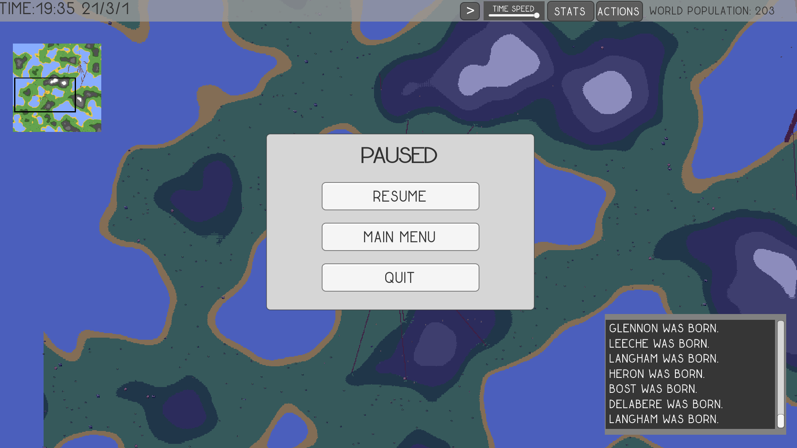

Figure Here is the pause menu.

# Appendix F Code

*To see code please see attached PDF on CD.*

Due to time constraints code was not commented as well I wanted. A lot of it does not adhere to good code standards. However much of the code related to map generation is well commented and has better code standards.